

Papyrus Guidelines



Draft TR-515 v1.3.02

July 14, 2023

Work in progress!

**Disclaimer**

THIS SPECIFICATION IS PROVIDED “AS IS” WITH NO WARRANTIES WHATSOEVER, INCLUDING ANY WARRANTY OF MERCHANTABILITY, NONINFRINGEMENT, FITNESS FOR ANY PARTICULAR PURPOSE, OR ANY WARRANTY OTHERWISE ARISING OUT OF ANY PROPOSAL, SPECIFICATION OR SAMPLE.

Any marks and brands contained herein are the property of their respective owners.

Open Networking Foundation

1000 El Camino Real, Suite 100, Menlo Park, CA 94025

[www.opennetworking.org](http://www.opennetworking.org)

©2018 Open Networking Foundation. All rights reserved.

Open Networking Foundation, the ONF symbol, and OpenFlow are registered trademarks of the Open Networking Foundation, in the United States and/or in other countries. All other brands, products, or service names are or may be trademarks or service marks of, and are used to identify, products or services of their respective owners.

**Important note**

This Technical Recommendations has been approved by the OIMT Project TST but has not been approved by the ONF board. This Technical Recommendation has been approved under the ONF publishing guidelines for 'Informational' publications that allow Project technical steering teams (TSTs) to authorize publication of Informational documents. The designation of '-info' at the end of the document ID also reflects that the project team (not the ONF board) approved this TR.

Table of Contents

1 Introduction 10

2 References 10

3 Abbreviations 10

4 Documentation Overview 11

5 Getting Papyrus Running 12

5.1 Applied Tool Versions 12

5.2 Downloading Papyrus 13

5.2.1 Downloading Latest Version 13

5.2.2 Downloading Applied Version 15

5.3 Papyrus Overview 25

5.4 Gendoc Plugin Installation 27

5.5 Importing a Model into Papyrus 29

5.6 Importing Common Models into a Model 33

5.7 Deleting a Project 37

6 GitHub Usage 37

6.1 Introduction to GitHub 37

6.2 Open Model Profiles and Tools on GitHub 38

🄌 Modeling Infrastructure Files on GitHub 39

6.2.1 Forking 39

6.2.2 Cloning 40

6.2.3 Model in Papyrus 43

6.2.4 Additional Remote Repository 44

6.2.5 Fetching Remote Repository 48

6.2.6 Updating Local Repository 48

6.2.7 Updating Own Remote Repository 50

6.3 Information Model on GitHub 52

6.3.1 Placeholder XxxModel 52

6.3.2 XxxModel Structure on GitHub 52

6.4 GitHub Work Flow 53

🄌 Model Structure 54

6.4.1 Forking 54

6.4.2 Cloning 54

6.4.3 Model in Papyrus 58

6.4.4 Developing the Model 59

6.4.5 Identify Changes to be upload to Repository 59

6.4.6 Updating Local Repository 60

6.4.7 Updating Own Remote Repository 60

6.4.8 Updating Remote Repository 62

6.4.9 Merging with Remote Repository 63

6.5 Downloading a Model from github for “Read Only Use” 63

7 Using Papyrus 65

7.1 Illustrative Profile and Model 65

7.2 Papyrus File Structure 67

7.3 Model Splitting 67

7.4 Constructing Modeling Environment for a new Model 69

7.4.1 Download model infrastructure files (CommonDataTypes, StyleSheets, Open Model Profiles) from Github 70

7.4.2 Create a new model in a new project 70

7.4.3 Copy downloaded model infrastructure files into new project 74

7.4.4 Apply the Open Model Profiles to the new model 76

7.4.5 Create Default Packages 78

7.4.6 Add the Style Sheet to the new model 79

7.4.7 Load CommonDataTypes libraries into the new model 81

8 Generating Model Documentation 84

8.1 Introduction 84

8.2 Template usage 84

8.3 Basic template 85

8.4 Cover, contents, closing text etc 86

8.5 Figures from the model with interleaved text 86

8.6 Figure in alphabetical order with no interleaved specific text 88

8.7 Further explanation of the script 88

8.8 Test template for printing diagrams and associated text 88

8.9 Data Dictionary template overview 89

8.10 Adding the class and its stereotypes 89

8.11 Adding properties and stereotypes in tabular form 91

8.12 Adding complex data types 93

8.13 Adding other data types 93

8.13.1 Enumeration Types 93

8.13.2 Primitive Types 94

8.14 Using Fragments 95

8.14.1 Fragment Definitions 95

8.14.2 Examples using Gendoc Fragments 108

8.15 Example complete template 110

8.16 Extending the template 111

8.17 Known issues 111

9 Importing RSA Models into Papyrus 111

9.1 Prerequisite 111

9.2 Import RSA Model into Papyrus 112

9.3 Replace RSA Profile by Papyrus Profile 114

9.4 Remove the “old” RSA files 114

10 Main Changes between Releases 115

10.1 Summary of main changes between version 1.0 and 1.1 115

10.2 Summary of main changes between version 1.1 and 1.2 115

10.3 Summary of main changes between version 1.2 and 1.3 115

**List of Figures**

Figure 4‑1: Specification Architecture 12

Figure 5‑1: Papyrus Download Page 13

Figure 5‑2: Content of the Papyrus Folder after Extracting the Zip-file 14

Figure 5‑3: Initial Papyrus Welcome Icon 14

Figure 5‑4: Selecting a Workspace 15

Figure 5.5: Eclipse Oxygen Modeling Tools Download Page 16

Figure 5.6: Content of the Eclipse Folder after Extracting the Zip-file 16

Figure 5‑7: Initial eclipse Welcome Icon 17

Figure 5‑8: Selecting a Workspace 17

Figure 5.9: Initial Welcome Page of Eclipse 18

Figure 5.10: Eclipse Version 19

Figure 5.11: Installing Papyrus (1) 20

Figure 5.12: Installing Papyrus (2) 20

Figure 5.13: Installing Papyrus (3) 21

Figure 5.14: Installing Papyrus (4) 22

Figure 5.15: Installing Papyrus (5) 23

Figure 5.16: Open Papyrus Perspective 24

Figure 5‑17: Required Display Setting 25

Figure 5.18: Outline of Papyrus Perspective 26

Figure 5‑19: Installing Gendoc (1) 27

Figure 5‑20: Installing Gendoc (2) 28

Figure 5‑21: Installing Gendoc (3) 28

Figure 5‑22: Papyrus Project Explorer / Model Explorer 29

Figure 5‑23: Papyrus Model Structure 30

Figure 5‑24: Importing a Model (1) 31

Figure 5‑25: Importing a Model (2) 32

Figure 5‑26: Open a Model 33

Figure 5‑27: Importing UML Primitive Types 34

Figure 5‑28: Importing Core Model Artifacts 35

Figure 5‑29: Selecting Core Model Artifacts 36

Figure 5‑30: Imported Core Model 36

Figure 5‑31: Delete a Project 37

Figure 6‑1: Recommended Repositories 38

Figure 6‑2: Recommended Work Flow for ToolChain Download 39

Figure 6‑3: Open Git Perspective 40

Figure 6‑4: Add Repository Choices 40

Figure 6‑5: Source Git Repository Window 41

Figure 6‑6: Local Destination Window 43

Figure 6‑7: ToolChain Branch Cloned to Local PC 43

Figure 6‑8: Create Additional Remote (1) 44

Figure 6‑9: Create Additional Remote (2) 45

Figure 6‑10: Create Additional Remote (3) 46

Figure 6‑11: Create Additional Remote (4) 47

Figure 6‑12: Create Additional Remote (5) 48

Figure 6‑13: Merge Request (1) 49

Figure 6‑14: Merge Request (2) 49

Figure 6‑15: Merge Result 50

Figure 6‑16: Push Request (1) 50

Figure 6‑17: Push Request (2) 51

Figure 6‑18: Push Request (3) 52

Figure 6‑19: Initial Model Structure on GitHub 53

Figure 6‑20: GitHub Work Flow 54

Figure 6‑21: Open Git Perspective 55

Figure 6‑22: Add Repository Choices 55

Figure 6‑23: Location of the Repository Address 56

Figure 6‑24: Source Git Repository Window 57

Figure 6‑25: Branch Selection Window 57

Figure 6‑26: Local Destination Window 58

Figure 6‑27: XxxModel Shown in Papyrus Model Explorer 59

Figure 6‑28: Unstaged Changes in Git Staging 59

Figure 6‑29: Add Files to Git Stage 60

Figure 6‑30: Staged Changes in Git Staging 60

Figure 6‑31: Push Updated Branch to Remote Repository 61

Figure 6‑32: Push Confirmation Window 62

Figure 6‑33: Compare in Modeler’s Remote Repository 62

Figure 6‑34: Detailed Comparison in Modeler’s Remote Repository 63

Figure 6‑35: Download XxxModel Repository 64

Figure 6‑36: Importing the XxxModel into Papyrus (1) 64

Figure 6‑37: Importing the XxxModel into Papyrus (2) 65

Figure 7‑1: Illustrative UML Profile 66

Figure 7‑2: Illustrative Core Model 67

Figure 7‑3: Profile Associated to the Model 67

Figure 7‑4: Papyrus File Structure 67

Figure 7‑5: Papyrus File Structure after Splitting 68

Figure 7‑6: Imported UML Artifacts 69

Figure 7‑7: Building Modeling Infrastructure 70

Figure 7‑8: Downloaded Model Infrastructure Files 70

Figure 7‑9: Creating a new Papyrus Project (1) 71

Figure 7‑10: Creating a new Papyrus Project (2) 71

Figure 7‑11: Creating a new Papyrus Project (3) 72

Figure 7‑12: Creating a new Papyrus Project (4) 73

Figure 7‑13: Creating a new Papyrus Project (5) 73

Figure 7‑14: CommonDataTypes and UMLProfiles Folders on Local PC 74

Figure 7‑15: CommonDataTypes and UMLProfiles Folders pasted to Model Folder 74

Figure 7‑16: .project Files to be deleted from the Folders 75

Figure 7‑17: Model Infrastructure Files in XxxModel Project 76

Figure 7‑18: Applying Profiles (1) 76

Figure 7‑19: Applying Profiles (2) 77

Figure 7‑20: Applying Profiles (3) 78

Figure 7‑21: Profiles Applied 78

Figure 7‑22: Default Package Structure 79

Figure 7‑23: Creating a Class Diagram 79

Figure 7‑24: Adding Class Diagram Style Sheet (1) 80

Figure 7‑25: Adding Class Diagram Style Sheet (2) 80

Figure 7‑26: Adding Class Diagram Style Sheet (3) 80

Figure 7‑27: Adding Class Diagram Style Sheet (4) 81

Figure 7‑28: Loading CommonDataTypes Libraries (1) 81

Figure 7‑29: Loading CommonDataTypes Libraries (2) 82

Figure 7‑30: Loading CommonDataTypes Libraries (3) 83

Figure 7‑31: Loading CommonDataTypes Libraries (4) 83

Figure 8‑1: Initiating Gendoc for a particular template 85

Figure 8-2 [diagramTitle/] 96

Figure 8-3 [diagramTitle/] 97

Figure 9‑1: Installing Papyrus Component “RSA Model Importer” 112

Figure 9‑2: Importing .emx Model 113

Figure 9‑3: Associated Papyrus Profile 114

**List of Tables**

**Table 1: Attributes for [cl.name/]** 91

Table 2: Attributes for [dt.name/] 93

Table 3: Attributes for [cl.name/] 98

Table 4: Attributes for [cl.name/] 98

Table 5: Attributes for [dt.name/] 100

Table 6: Attributes for [cl.name/] 101

Table 7: Attributes for [dt.name/] 104

Table 8: Attributes for [cl.name/] 109

Document History

|  |  |  |
| --- | --- | --- |
| **Version** | **Date** | **Description of Change** |
| 1.0 | March 13, 2015 | Initial version |
| 1.1 | Nov. 30, 2015 | Version 1.1 A summary of main changes between version 1.0 and 1.1 is contained in section 10.1. |
| 1.2 | Sept. 20, 2016 | Version 1.2 A summary of main changes between version 1.1 and 1.2 is contained in section 10.2. |
| 1.3 | July, 2018 | Version 1.3 A summary of main changes between version 1.2 and 1.3 is contained in section 10.3. |
| 1.3.01 | Aug. 27, 2018 | Initial version for 1.4 development Reference to IISOMI 514 “UML Modeling Guidelines” updated. |
| 1.3.02 | July 14, 2023 | Revision marks from v1.3.01 accepted. New section 7.5 “Tips & Tricks” added New section 7.5.1 “Class Diagram: Auto Size” added Sections on Papyrus installation (5.1) updated and made “version neutral” Section 5.3 “Gendoc Plugin Installation” made “version neutral” “Insert Constraints” Fragment added in section 8.15.1.16 New section 8.14 “Adding «ExtendedComposite» associations” added New section 6.5 “Working with specific Commits” added New section 7.5.2 “Display Signals/Notifications defined inside an Object Class” added New section 8.19 on Example Gendoc Scripts added |

# Introduction

This Technical Recommendation has been developed within IISOMI (**I**nformal **I**nter-**S**DO **O**pen **M**odel **I**nitiative) and is published by ONF.

IISOMI is an open source project founded by UML model designers from various SDOs like ETSI NFV, ITU-T, MEF, ONF and TM Forum.  
The goal is to develop guidelines and tools for a harmonized modeling infrastructure that is not specific to any SDO, technology or management protocol and can then be used by all SDOs.  
The deliverables are developed in an open source community under the “Creative Commons Attribution 4.0 International Public License”.

This document defines the guidelines that have to be taken into account during the creation of a protocol-neutral UML (Unified Modeling Language) information model using the Open Source tool Papyrus. The Guidelines are not specific to any SDO, technology or management protocol. References are written in an SDO-neutral form, enclosed by “{ }”; each SDO will have an SDO-specific “mapping table” for these placeholders:

* XxxModel  
  Any Papyrus UML model.
* {XxxModel}  
  Identifies the URI of the GitHub repository containing the XxxModel.

# References

1. Papyrus Eclipse UML Modeling Tool (<https://www.eclipse.org/papyrus/>)
2. Eclipse (<https://eclipse.org/>)
3. Unified Modeling Language™ (UML®) (<http://www.uml.org/>)
4. IISOMI 514 “UML Modeling Guidelines”  
   Last published version 🡪 [TR-514 v1.3-info](https://3vf60mmveq1g8vzn48q2o71a-wpengine.netdna-ssl.com/wp-content/uploads/2018/08/TR-514_UML_Modeling_Guidelines_v1.3-1.pdf) (7/2018)
5. IISOMI Wiki  
   (<https://wiki.opennetworking.org/display/OIMT/IISOMI>)
6. Open Source SDN Project EAGLE  
   (<https://github.com/OpenNetworkingFoundation/EAGLE-Open-Model-Profile-and-Tools>)
7. OpenModelProfile  
   (<https://github.com/OpenNetworkingFoundation/EAGLE-Open-Model-Profile-and-Tools/tree/ToolChain/UmlProfiles>)
8. Eclipse Gendoc Releases (<https://www.eclipse.org/gendoc/>downloads/download.php)
9. Papyrus Releases Overview  
   (https://wiki.opennetworking.org/display/OIMT/Papyrus+Releases)

# Abbreviations

API Application-Programming-Interface

ARO Association Resources Online™

ASCII American Standard Code for Information Interchange

DS Data Schema

IDE Integrated Development Environment

IISOMI Informal Inter-SDO Open Model Initiative

IM Information Model

IMP Information Modeling Project (ONF Services Area)

ITU-T International Telecommunication Union – Telecommunication Standardization Sector

JSON JavaScript Object Notation

NBI NorthBound Interface

OF Open Flow

OT Optical Transport

RSA Rational Software Architect (UML tool from IBM)

SDO Standards Developing Organization

UML Unified Modeling Language

URI Uniform Resource Identifier

URL Uniform Resource Locator

XML Extensible Markup Language

WG Working Group

# Documentation Overview

This document is part of a suite of guidelines. The location of this document within the documentation architecture is shown in Figure 4‑1 below:



Figure 4‑1: Specification Architecture

# Getting Papyrus Running

The Open-Source UML tool Papyrus is a plug-in for the Open-Source Integrated Development Environment (IDE) Eclipse.

This section explains how to get Papyrus running on the target PC and how to import a model. Working with sub-models is described in clause 7.3.

Note: These guidelines use Eclipse Oxygen / Papyrus 3.4.2 for the figures just as an example.

## Downloading Papyrus

An overview of the Papyrus Releases is provided in [9].

 Note that this page is just a snapshot of the releases at the indicated date. 

### Downloading Latest Version

This is the easiest way of getting Papyrus. In this download approach, the Papyrus package already includes Eclipse.

Installing the latest available versions of Eclipse and Papyrus is **not recommended** since the latest available versions most likely might not be tested yet and the migration of models created in previous versions may cause errors.

The latest version of Papyrus can be downloaded as a complete software package from the Papyrus homepage: <https://eclipse.org/papyrus/download.html>. The software package contains Papyrus and also the corresponding Eclipse software; i.e., Eclipse need not already be available on the target PC.

Papyrus is available for various platforms:

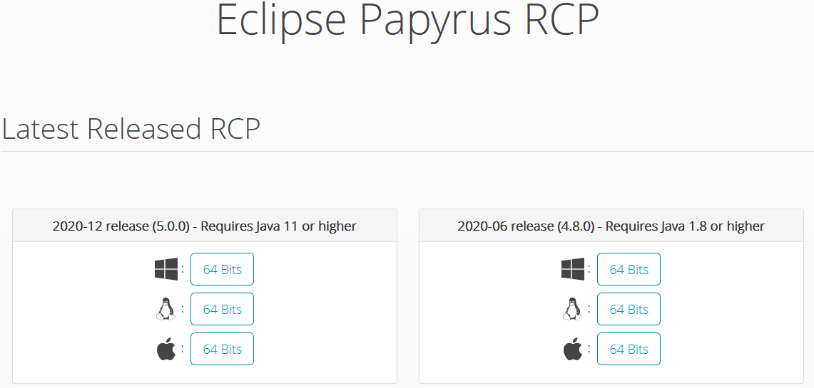

Figure 5‑1: Papyrus Download Page

Once downloaded, just extract the downloaded zip-file (i.e., Papyrus (Eclipse) need not be “installed” on the target PC):

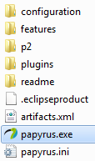

Figure 5‑2: Content of the Papyrus Folder after Extracting the Zip-file

To launch Papyrus, double-click on the  file.



Figure 5‑3: Initial Papyrus Welcome Icon

After launching Papyrus, a default  folder is created in the home directory (…/users/<users name>/). The workspace configuration information is contained in the folder: (which is automatically created):  
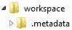.

Any empty (need not be empty but is recommended) folder - anywhere - can be used as a workspace-folder. The workspace can be selected during the launch of Papyrus.

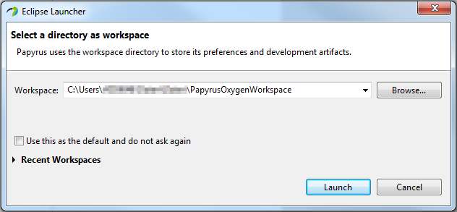

Figure 5‑4: Selecting a Workspace

Continue at clause 5.3.

### Downloading a Specific Version

In this approach, one needs to download and launch Eclipse and then add the Papyrus plug-in.

This is the recommended approach since it makes sure that the agreed version of Eclipse and Papyrus get “installed” on the PC.

Warning:  
Avoid to use the Help:: and uncheck Window::Preferences::Install/Update   
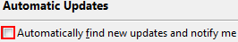  
which may install other versions of Eclipse and Papyrus!

[9] provides the links to various Eclipse and Papyrus releases.

 The links in [9] reference the required “Eclipse Modeling Tools” package.   
 I.e., not the Standard version.

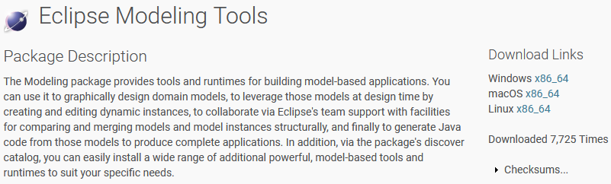

Figure 5.5: Eclipse Modeling Tools Download Page

Once downloaded, just extract the downloaded zip-file (i.e., Eclipse need not be “installed” on the target PC):

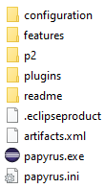

Figure 5.6: Content of the Eclipse Folder after Extracting the Zip-file

To launch Eclipse, double-click on the  file.



Figure 5‑7: Initial eclipse Welcome Icon

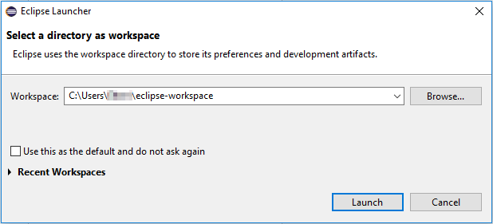

Figure 5‑8: Selecting a Workspace

After launching Eclipse, a default  folder is created in the home directory (…/users/<users name>/). The workspace configuration information is contained in the folder:  
.

Any empty folder (need not be empty but is recommended) - anywhere - can be used as a workspace-folder. The workspace can be selected during the start of Eclipse.

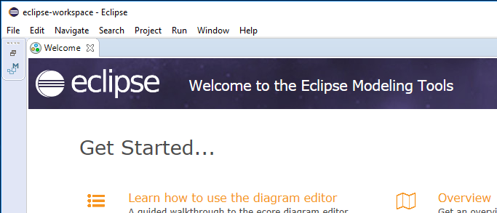

Figure 5.9: Initial Welcome Page of Eclipse

Close the  tab at the upper left corner.

Click  and select  to check that the correct version is installed:

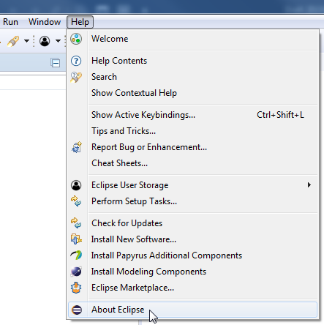  
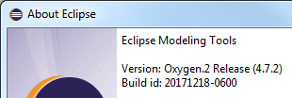

Figure 5.10: Eclipse Version

Eclipse is now ready for use.

To add Papyrus, click menu  and then :

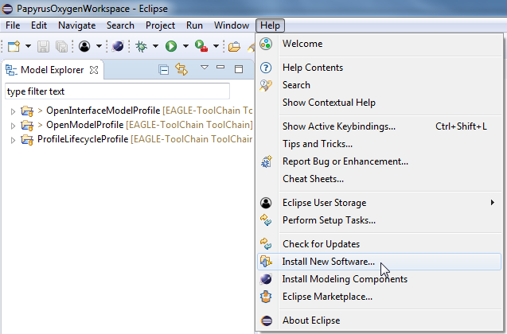

Figure 5.11: Installing Papyrus (1)

Click  in the  window, then add a name and the corresponding Papyrus update site as provided in (#.#.x) in the Papyrus Release Number column in [9] in the  window:

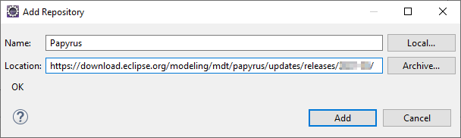

Figure 5.12: Installing Papyrus (2)

Click  and then make sure you do not check  and select the required software in the  window:

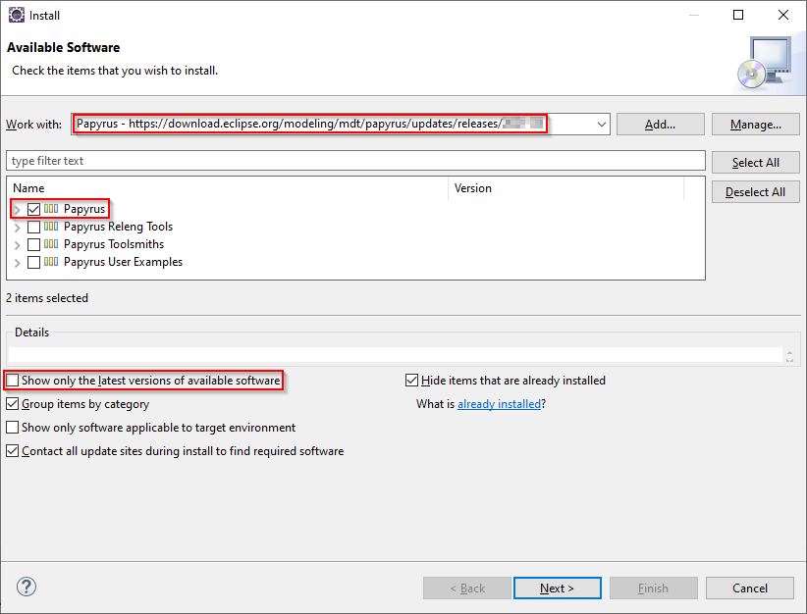

Figure 5.13: Installing Papyrus (3)

Click .

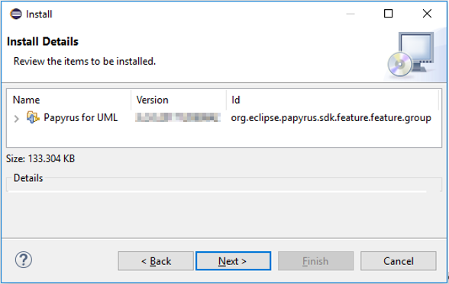

Figure 5.14: Installing Papyrus (4)

The correct Papyrus version can be checked in the appearing  window.

Click , accept the license agreement  and then click :

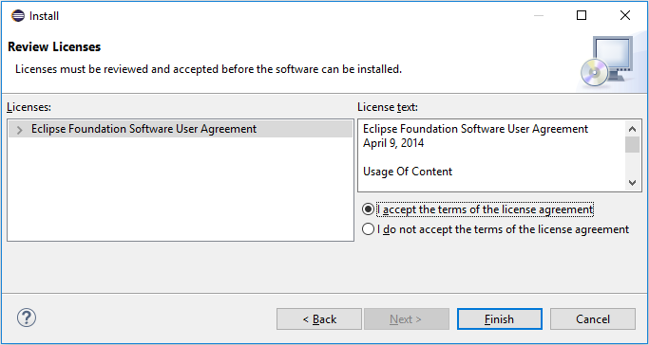

Figure 5.15: Installing Papyrus (5)

After Papyrus is installed successfully, Eclipse need to be restarted.

After restarting Eclipse switch to the Papyrus Perspective (if not already displayed) by

* either going via menu , Perspective, Open Perspective, Other…:  
  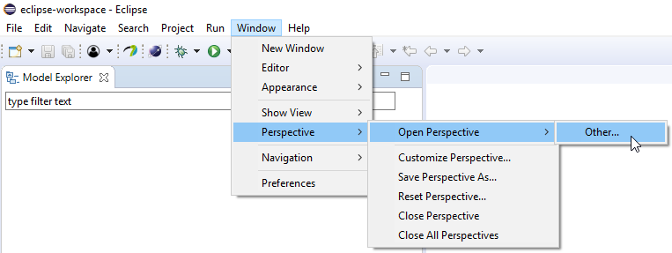
* or by clicking the Open Perspective-button () at the top right side of the screen:  
  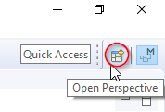

and then selecting :

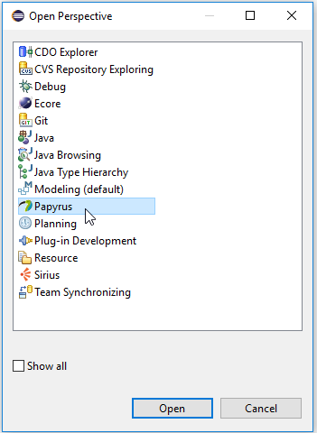 🡪 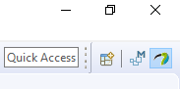

Figure 5.16: Open Papyrus Perspective

 Papyrus content can only be viewed properly if the computer display is set to 100 %. 

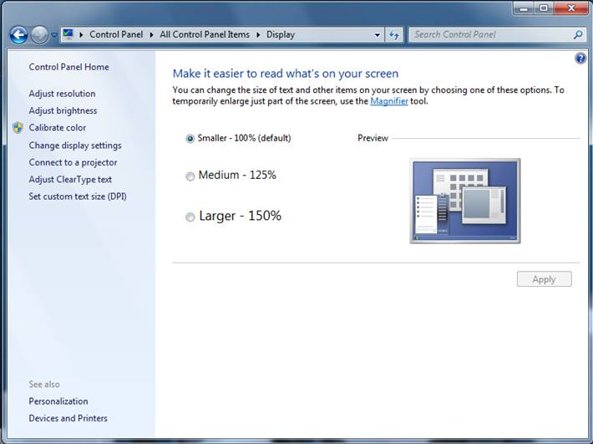

Figure 5‑17: Required Display Setting

## Papyrus Overview

The outline of the Papyrus Perspective presents different panes/panels and toolbars:

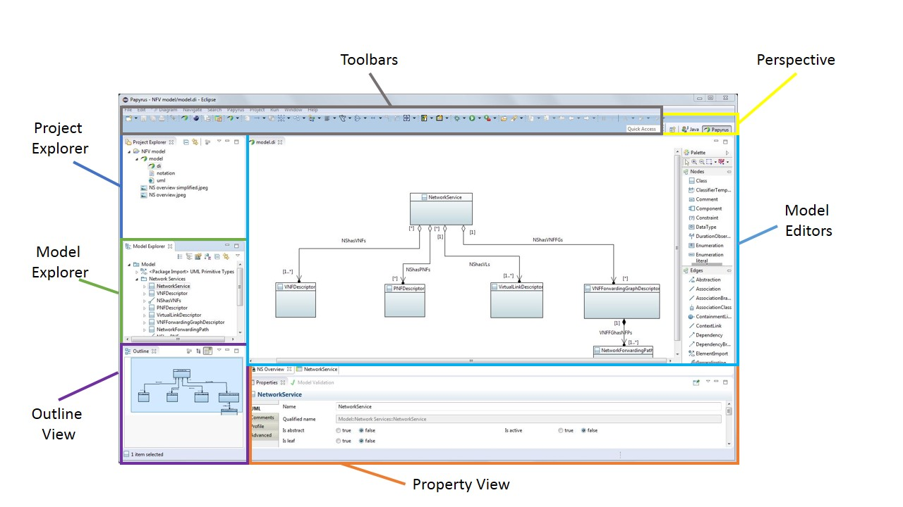

Figure 5.18: Outline of Papyrus Perspective

* **Perspective:** it provides the modeling context and the layout of the windows, as well as the definition of the menus and toolbars. For using Papyrus, it shall always be set to “Papyrus”.
* **Project Explorer:** it is used to manage Papyrus projects at system level. It provides a view on the model files in the workspace folder.
* **Model Explorer:** it provides the internal view of the model selected in the Project Explorer. It is a tree-based model editor for the whole model. If the Project Explorer contains several models, only one at a time can be selected to be edited in the Model Explorer.
* **Model Editors:** it allows graphic edition of the model via diagrams. Class diagrams are the only type of diagram mandated.
* **Property View:** it is a form-based editor allowing to view and edit the detailed property of a given element.
* **Outline View:** it provides a read-only view of the model presented in the Model Editor.

## Gendoc Plugin Installation

The Gendoc plugin is used in conjunction with a document template. The template contains instructions that enable generation of a Microsoft Word document. The document can include extracts from the model such as diagrams, class definitions, attribute definitions along with their stereotypes etc. as well as figures and text directly entered into the template. This clause provides instructions on how to install Gendoc followed by guidance on construction of Gendoc templates along with example fragments of templates.

Click menu  and then :

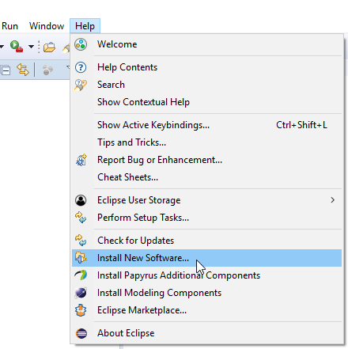

Figure 5‑19: Installing Gendoc (1)

Click  and enter the appropriate Gendoc update site from [8]:

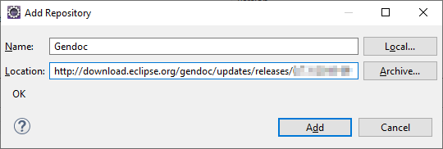

Figure 5‑20: Installing Gendoc (2)

Select Gendoc:

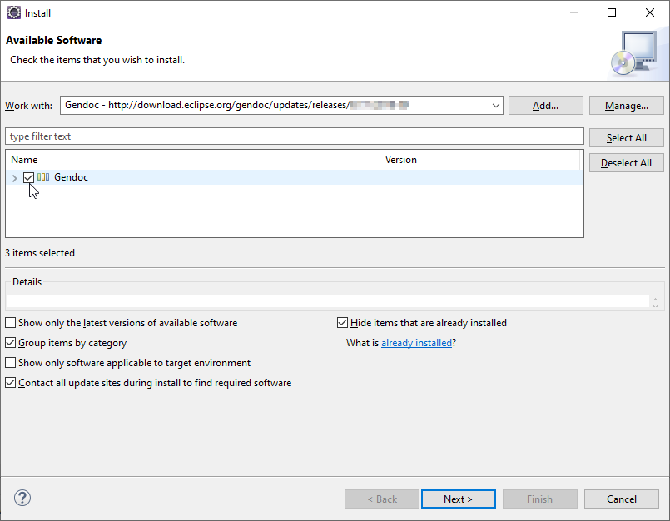

Figure 5‑21: Installing Gendoc (3)

Then click  and follow the instructions.

## Importing a Model into Papyrus

Note: How to create new models from scratch is described in 7.4.

The Papyrus Perspective shows a Project Explorer and a Model Explorer:

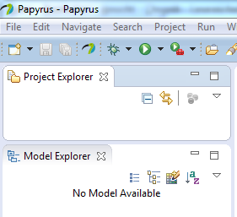

Figure 5‑22: Papyrus Project Explorer / Model Explorer

Notes:  
Models cannot exist on their own. Every model needs to be contained in a project. A project can contain zero or more models.  
The  window provides a view on the model files in the workspace-folder. The  window provides the internal view of the model selected in the. The  can only handle (edit) one model at a time.

The actual interface specification is contained in the Information Model and the additional properties of the UML artifacts are defined in a Profile Model. It is possible to organize the two models in a single project (*Alternative 1* in the figure below) or in two separate projects (*Alternative 2* in the figure below).

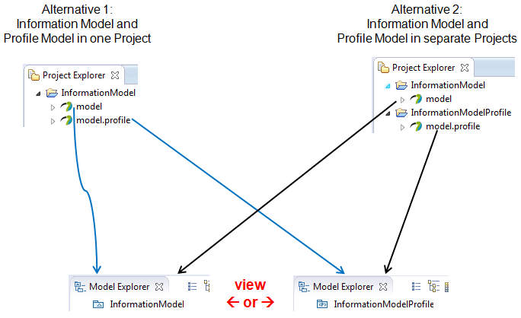

Figure 5‑23: Papyrus Model Structure

Clause 6.2 explains how to access the Open Model Profiles in GitHub.

Each project folder contains a .project file. Each model folder – profiles are also models – contains a .di, .notation and .uml file.

The following steps explain how to import a model (profile or model) into Papyrus.

 The Profile should be imported first.   
 It is also possible to import the Model first,  
 but the Profile shall be available before the model is opened the first time.

Right click in the  area opens the menu containing the -button:

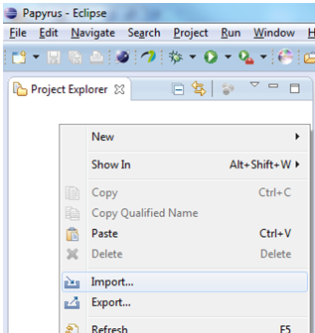 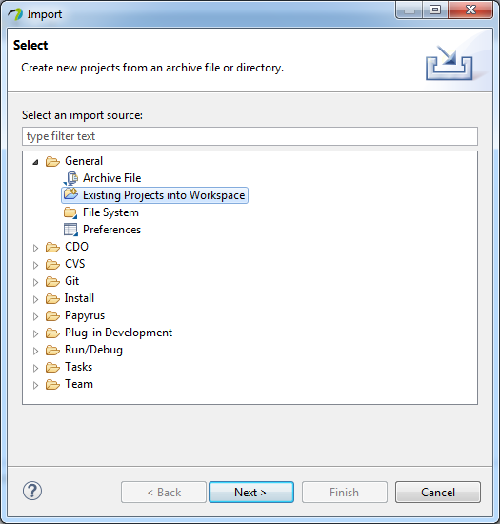

Figure 5‑24: Importing a Model (1)

Select the  option when the profile - that has to be imported - contains a  file. Otherwise create a new project and then import the profile using the  option.

Click  and then point via 

* to the folder containing the extracted files: 
* to the zip-file containing the files: .

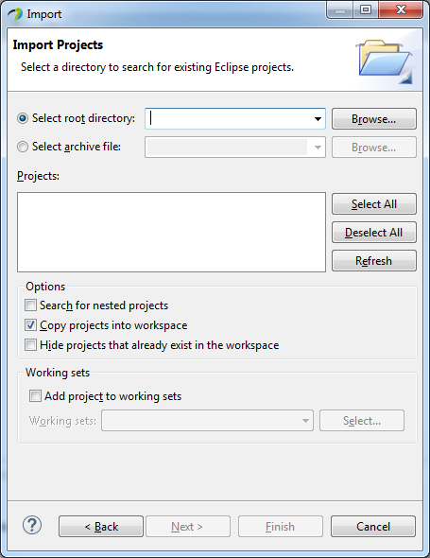

Figure 5‑25: Importing a Model (2)

THEN select the option  if the model files shall be copied into the workspace, otherwise Papyrus only creates a pointer and works with the files contained in the extracted folder:  
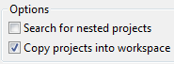

Click .

Note:  
The profile/model files can be located anywhere on the PC. It is not necessary to copy the files into the workspace-folder.

A double click e.g., on  in the  opens the XxxModel in the :

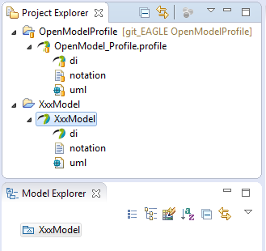

Figure 5‑26: Open a Model

Now the model can be used.

## Importing Common Models into a Model

It may be necessary to import the common UML Primitive Types (i.e., Boolean, Integer, String). This can be done by a right-click on the model pacakge  then going to  /  and then select :

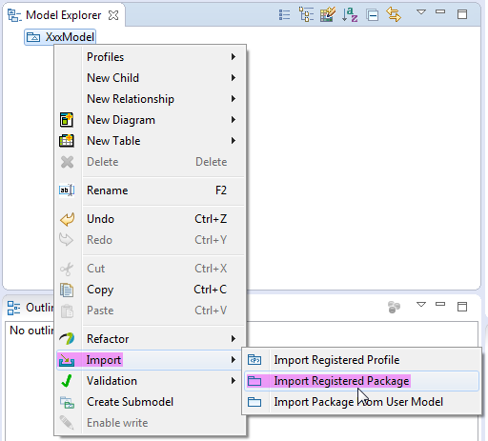 🡪 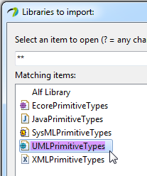

Figure 5‑27: Importing UML Primitive Types

It may also be necessary to relate artifacts in the sub-module to artifacts defined in the core model. This can be done by a right-click on the model package  then via  and  select  / :

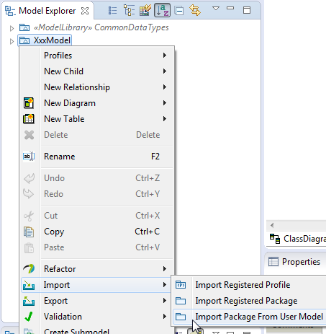  
  
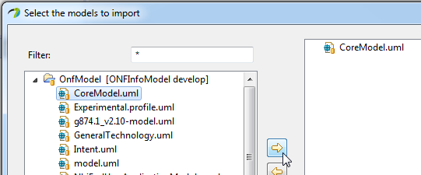

Figure 5‑28: Importing Core Model Artifacts

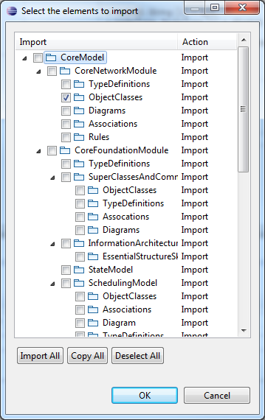

Figure 5‑29: Selecting Core Model Artifacts

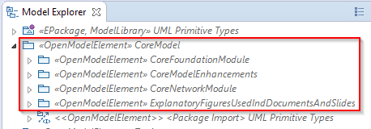

Figure 5‑30: Imported Core Model

## Deleting a Project

Projects can be deleted from the  by a right click on the project (e.g., ) and selecting .

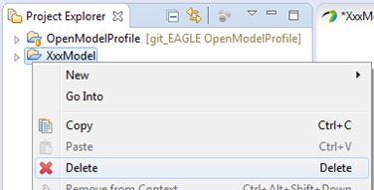

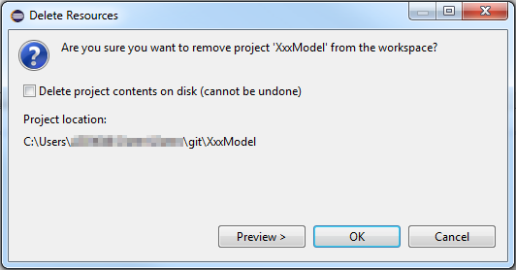

Figure 5‑31: Delete a Project

Note: When  is not checked the model will only be removed from the .

# GitHub Usage

## Introduction to GitHub



Wikipedia: “*Git is a widely-used source code management system for software development. It is a distributed revision control system with an emphasis on speed, data integrity, and support for distributed, non-linear workflows.*”

Git is a protocol which allows managing data in repositories on hosts. Such hosts are provided by many companies and organizations.



GitHub is a web-based git repository hosting service.

Note:  
These Guidelines describe the usage of repositories stored in GitHub. The usage of other hosting services is similar.

The work flow recommended in these Guidelines is based on the usage of four repositories:

* a repository on GitHub containing the published files
* a copy of the published repository located in my (user/modeler) remote repository on GitHub
* a copy of my remote repository located on my local PC
* a copy of my local repository in my local working directory  
  (all changes done by me will initially be stored in this working directory)



Figure 6‑1: Recommended Repositories

## Open Model Profiles and Tools on GitHub

IISOMI [5] is developing a set of SDO-neutral modeling infrastructure (common) artifacts such as:

* UML profiles  
  Contain the definition of additional properties for UML artifacts. The additional properties are described in the UML Modeling Guidelines [4].
* UML class diagram style sheets  
  Ensure a common look and feel of the UML class diagrams.
* common data types
* tools.

The following steps describe the recommended work flow for downloading these artifacts to the local PC for usage in Papyrus.

The following sub-sections correspond with the numbers  in Figure 6‑2.



Figure 6‑2: Recommended Work Flow for ToolChain Download

### 🄌 Modeling Infrastructure Files on GitHub

The artifacts are published in the ToolChain branch of the ONF Open Source EAGLE-Open-Model-Profile-and-Tools repository (<https://github.com/OpenNetworkingFoundation/EAGLE-Open-Model-Profile-and-Tools/tree/ToolChain>).

### Forking

The modeler needs to copy the repository into its own GitHub space; by clicking :



A copy of the complete repository is now contained in the modeler’s GitHub space:



The URI pointing to this repository is provided here:

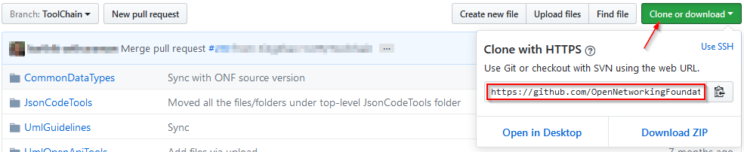

### Cloning

The ToolChain branch needs to be cloned to the modeler’s local repository. This is done using the git client that is contained in the Eclipse tool.

After Eclipse has been launched on the local PC, the git client can be started by clicking the Open Perspective button: and then choosing the  perspective.

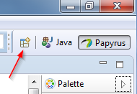🡪 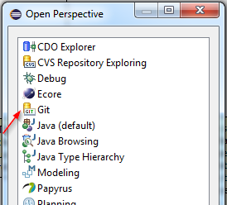

Figure 6‑3: Open Git Perspective

In the  window click on  or :

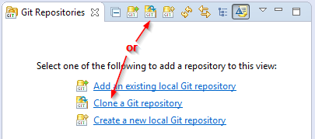

Figure 6‑4: Add Repository Choices

The URI of the repository is provided on the modeler’s GitHub space; see step 1.  
Copy this address (https://github.com/<modeler’s git user name>/EAGLE-Open-Model-Profile-and-Tools.git) into the URI field (the Host and Repository path fields are then automatically populated) and enter the modeler’s GitHub username and password.

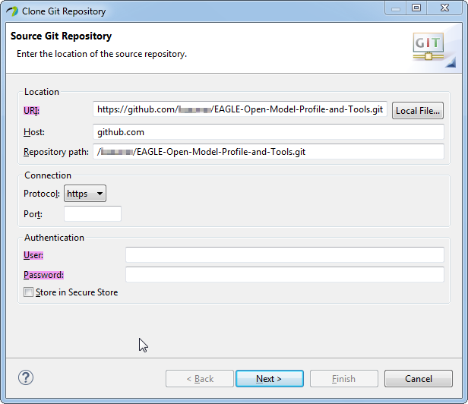

Figure 6‑5: Source Git Repository Window

Click  and select **only** the ToolChain branch:

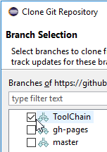

Click  and insert the destination directory on the local disk where the profile shall be stored.

 and  should be checked.

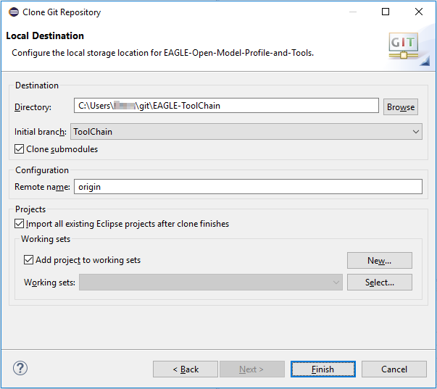

Figure 6‑6: Local Destination Window

Click . The ToolChain branch is now downloaded to the local PC.

### Model in Papyrus

The  window should then contain the following files:

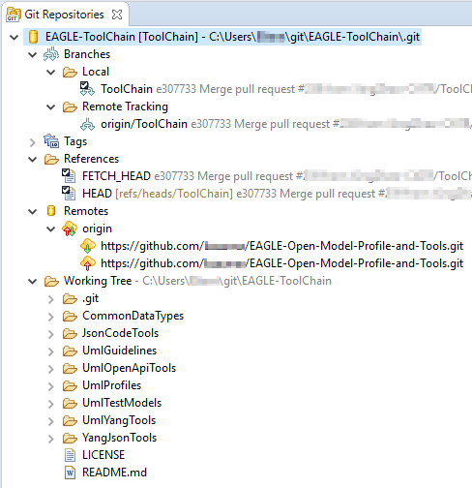

Figure 6‑7: ToolChain Branch Cloned to Local PC

Since the  checkbox was selected, all Papyrus projects contained in the ToolChain branch automatically appear in the  window in the Papyrus perspective. This can be rechecked in the perspective:

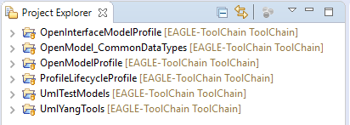

### Additional Remote Repository

The following steps describe how to update the local ToolChain files.  
The latest version of the ToolChain files is stored in the EAGLE-Open-Model-Profile-and-Tools remote repository on GitHub. This repository needs to be added to the list of Remotes.  
This can be configured in the  window of the Git perspective. Right click on  and select Create Remote …:

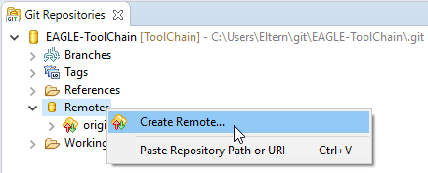

Enter a name for the remote branch and select :

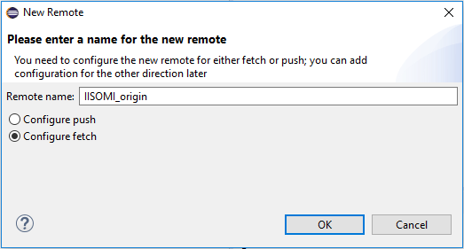

Figure 6‑8: Create Additional Remote (1)

Click .

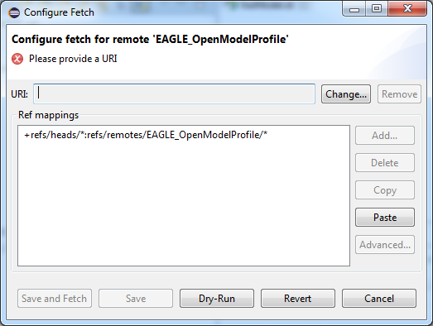

Figure 6‑9: Create Additional Remote (2)

Click  to enter the URI of the EAGLE repository   
(<https://github.com/OpenNetworkingFoundation/EAGLE-Open-Model-Profile-and-Tools.git>):

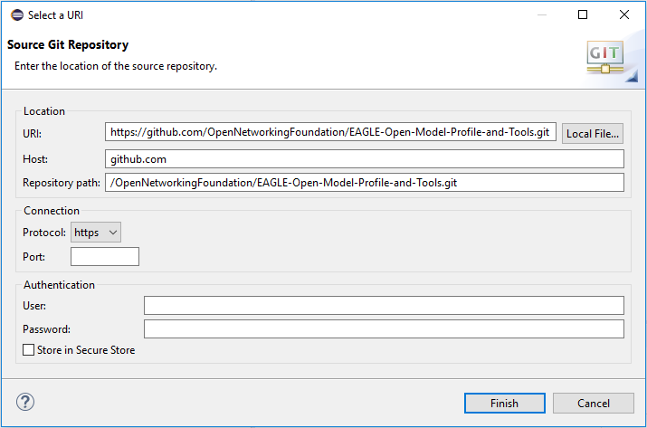

Figure 6‑10: Create Additional Remote (3)

Enter user name and password and click .  
Delete the existing item in the Configure Fetch window:

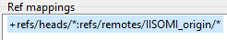

Click then  in the Configure Fetch window. **Enter a space** in the Source field to get the list of the branches and select :

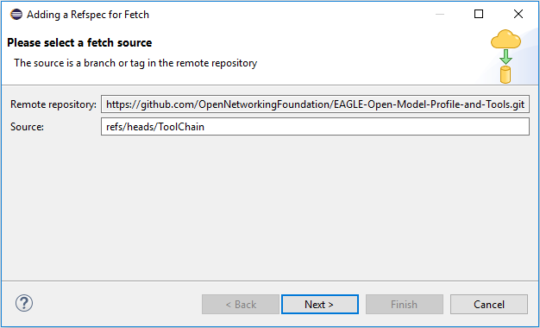

Figure 6‑11: Create Additional Remote (4)

Click  and then 

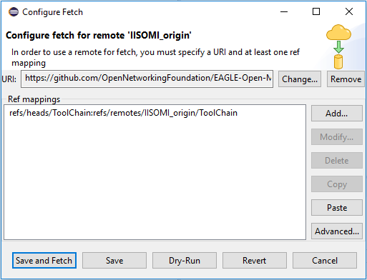

Figure 6‑12: Create Additional Remote (5)

Click .  
The additional branch is added to the Remotes list:

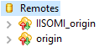

### Fetching Remote Repository

To align the ToolChain version in the local repository with an updated version on GitHub go to the  window of the Git perspective. Right click on  in the  list and select :

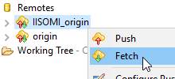

After the request, a Fetch Results window lists

* either the commits that have been done on the version in the EAGLE-Open-Model-Profile-and-Tools repository since the local repository has been updated
* or everything is already up to date.

### Updating Local Repository

Then the local branch, which has been checked out, needs to be merged with the new version that was fetched in Step 5.  
Right click on the local OpenModelProfile branch and then select :

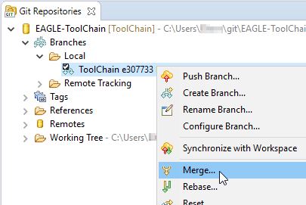

Figure 6‑13: Merge Request (1)

Select the branch that needs to be merged into the ToolChain branch:

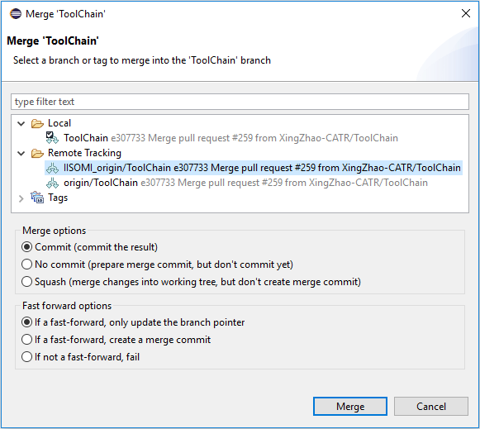

Figure 6‑14: Merge Request (2)

Then click  and acknowledge the Merge Results window:

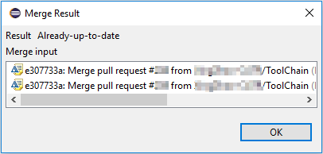

Figure 6‑15: Merge Result

### Updating Own Remote Repository

To update also the own remote repository right click on the local ToolChain branch and then select :

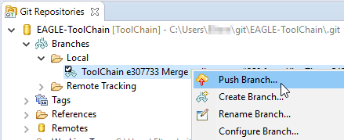

Figure 6‑16: Push Request (1)

In the Push Branch window make sure that the modeler’s remote Github repository is selected as the destination:

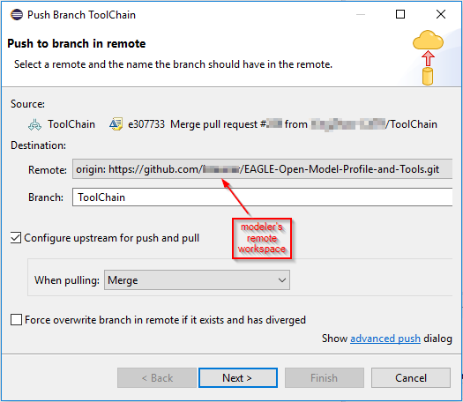

Figure 6‑17: Push Request (2)

Click .

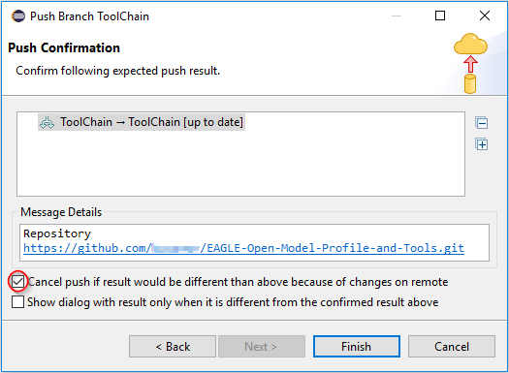

Figure 6‑18: Push Request (3)

Click 

## Information Model on GitHub

### Placeholder XxxModel

Note:  
The following GitHub usage description is using XxxModel as a placeholder for any Paprus UML model.

The XxxModel is stored in a repository on GitHub. The link to the repository is {XxxModel}.

The model development architecture identifies two groups of people that are working with the model: (a) Modelers who do the actual writing of the model pieces, and (b) Administrators who establish the working environment and control the “master copy” of the XxxModel.

### XxxModel Structure on GitHub

The XxxModel is contained in a “master branch” on GitHub. A copy of this master branch is provided in the “develop branch”.



Figure 6‑19: Initial Model Structure on GitHub

The modeling teams are developing their part of the model in their develop branch. All updates of the individual develop branches will be merged back to the master branch from time to time[1].

## GitHub Work Flow

The following steps describe the work flow that a modeler has to follow when developing the XxxModel.

Clause 6.5 describes a more easy way of getting the XxxModel to the local PC. This way is restricted to “read only viewers” of the model since it does not allow to commit changes back to GitHub.

The sub-sections correspond with the numbers  in Figure 6‑20.



Figure 6‑20: GitHub Work Flow

### 🄌 Model Structure

The administrator has established the XxxModel repository (containing the master and develop branches) in the SDO git space under the following URL: {XxxModel}.

### Forking

The modeler needs to copy the repository from the SDO git space into its own git space; by clicking on :



### Cloning

An individual modeler works only in the develop branch. This specific branch needs to be copied to the modeler’s local PC into a local repository. This is done using the git client that is contained in the Eclipse tool on the local PC.

 Make sure that the Eclipse Workspace that is selected during launch of   
Eclipse does not already contain the XxxModel project.

Note:  
More than one version of the model can only be maintained on the local PC if they are in different Eclipse Workspaces.

After the Eclipse has been launched in the local PC, the git client can be started by clicking the “Open Perspective” button: and then choosing the  perspective.

Note: Depending on the Eclipse version, the git client may have another name (including the term “Git”)[2].

🡪 

Figure 6‑21: Open Git Perspective

In the  window click on  or :



Figure 6‑22: Add Repository Choices

Copy and paste the address that is provided on the web page of the XxxModel in the modeler’s git space:

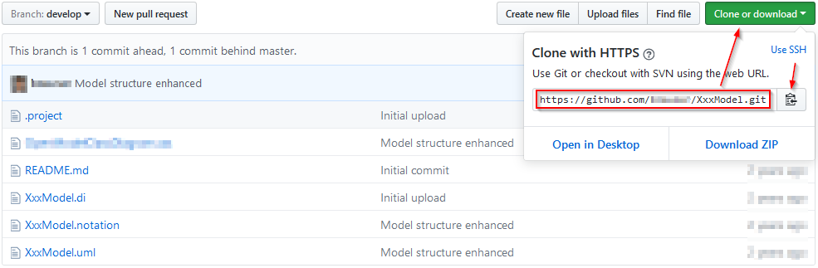

Figure 6‑23: Location of the Repository Address

Copy this address (https://github.com/<modeler’s git user name>/XxxModel.git) into the URI field (the Host and Repository path fields are then automatically populated) and enter the modeler’s GitHub username and password.

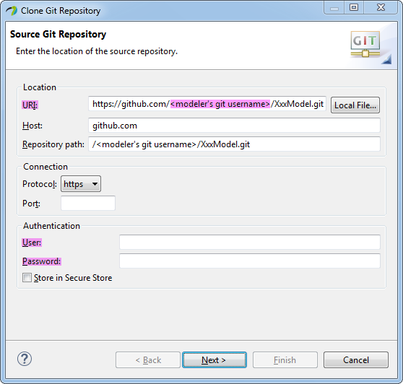

Figure 6‑24: Source Git Repository Window

Click  and select **only** the develop branch.

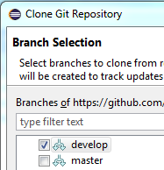

Figure 6‑25: Branch Selection Window

Click  and insert the destination directory on the local disk where the model shall be stored.

 and  should be checked.

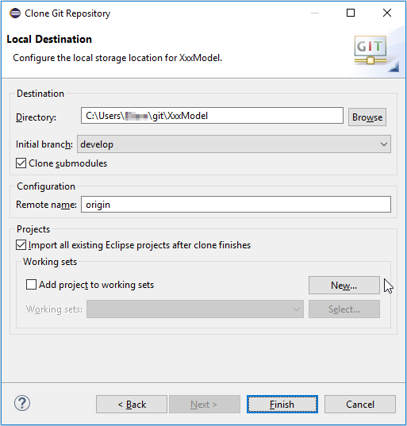

Figure 6‑26: Local Destination Window

Click . The selected branch of the XxxModel is now downloaded to the local PC.

### Model in Papyrus

Since the  checkbox was selected, the XxxModel project should automatically appear in the  window in the Papyrus perspective. This can be rechecked in the  perspective:

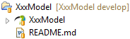.

### Developing the Model

A double-click on  starts the modeling in Papyrus and opens the XxxModel in the  window.

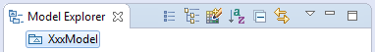

Figure 6‑27: XxxModel Shown in Papyrus Model Explorer

The designer of the XxxModel can now develop the model.

Note: Papyrus “Save” updates only the local working Directory

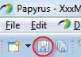.

### Identify Changes to be upload to Repository

After saving the changes in Papyrus the updated files are shown in  in the  perspective.

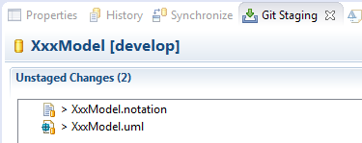

Figure 6‑28: Unstaged Changes in Git Staging

Pick all XxxModel files, right-click and select :

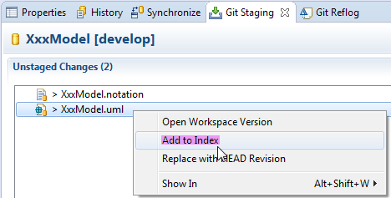

Figure 6‑29: Add Files to Git Stage

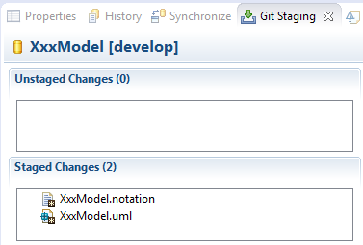

Figure 6‑30: Staged Changes in Git Staging

### Updating Local Repository

To commit the staged changes to the modeler’s local repository, provide a commit message describing the changes that were done and then click on .

### Updating Own Remote Repository

Steps 4 – 6 are all dealing only with changes on the local PC of the modeler. To save the changes to the modeler’s remote repository, right-click on the repository in the  tab and select .

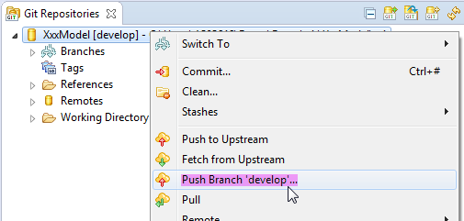

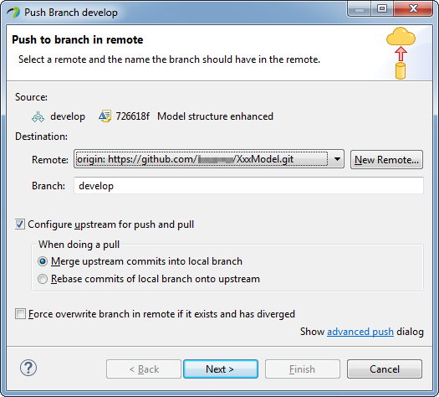

Figure 6‑31: Push Updated Branch to Remote Repository

Make sure  and  are checked.

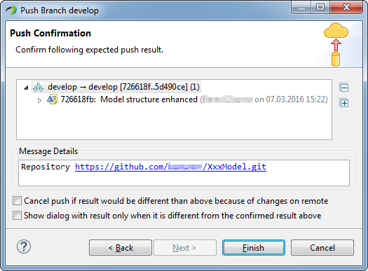

Figure 6‑32: Push Confirmation Window

Finally click .

### Updating Remote Repository

Steps 3 – 7 can be done as often as necessary.  
Once all updates of the sub-model for the next release of the XxxModel are finished, the modeler needs to notify the administrators that a stable version is ready. This is done by a pull request from the modeler’s remote repository using  or .

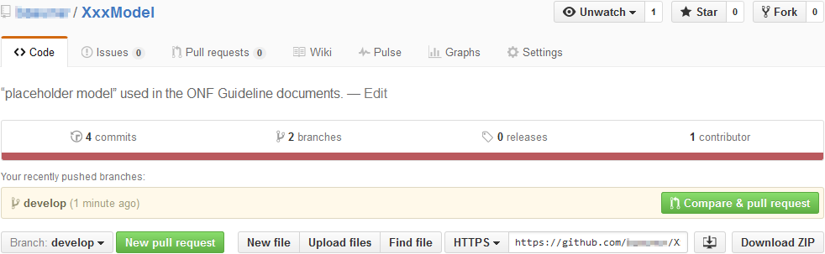

Figure 6‑33: Compare in Modeler’s Remote Repository

After click on  or  git provides a detailed comparison of all changes done in all files.

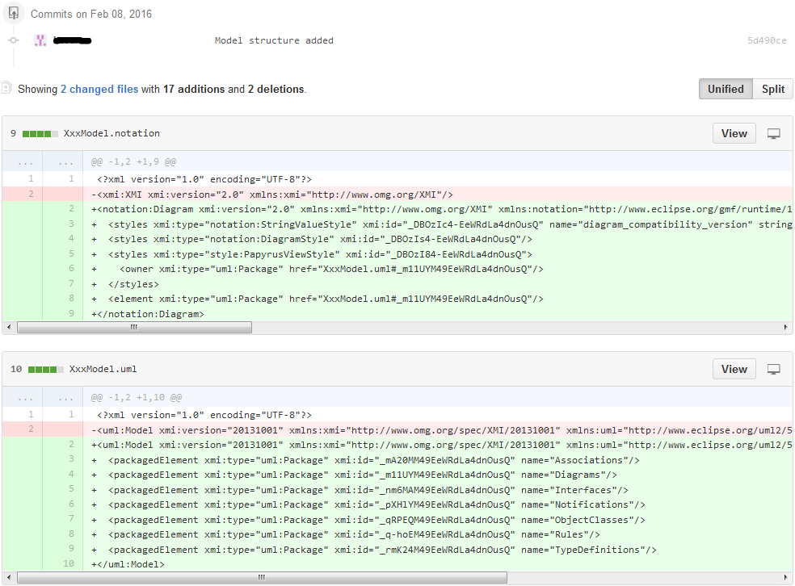

Figure 6‑34: Detailed Comparison in Modeler’s Remote Repository

The modeler can review the changes, add a comment to this updated version of the sub-model and then send the pull request by clicking on .

### Merging with Remote Repository

The administrator of the SDO remote repository receives the pull request and can merge the updates into its repository.

## Working with specific Commits

Git is organizing the repository in a continuous series of commits. A commit identifies a specific state of the files in the repository.  
Tags are used to add user-friendly names to specific commits, e.g., a version name.

A specific commit, named by a tag, can be checked out to the Working Tree directory by a right click on the relevant tag  followed by a click on .

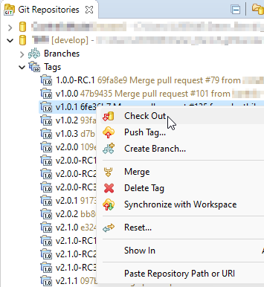

Figure 6‑34: Checking out a specific commit identified by a tag

The checked-out tag is identified by a checkbox attached to the tag icon: .

## Downloading a Model from github for “Read Only Use”

This clause describes an easier way of getting the XxxModel to the local PC. This way is restricted to “read only viewers” of the model since it does not allow to commit changes back to GitHub.

The XxxModel repository is located in the SDO git space under the following URL: {XxxModel}.

Select the right branch , click the  and  buttons of the github web page to download the repository to the local PC.

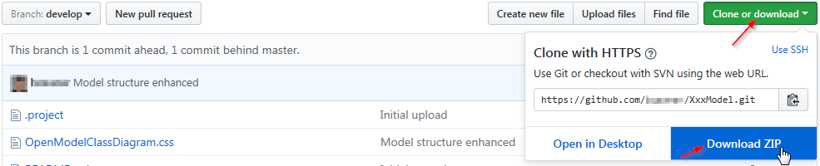

Figure 6‑35: Download XxxModel Repository

Import the zip-file to the desired Eclipse Workspace.  
Right click in the  area opens the menu containing the -button:

 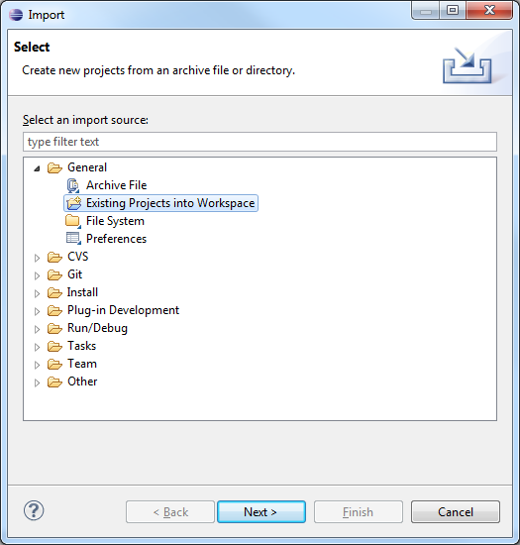

Figure 6‑36: Importing the XxxModel into Papyrus (1)

Select the  option since the downloaded repository contains already the  files for the model and profile.

Click  and then point via  to the zip file downloaded in step 1.

The XxxModel is already selected in the Projects box.

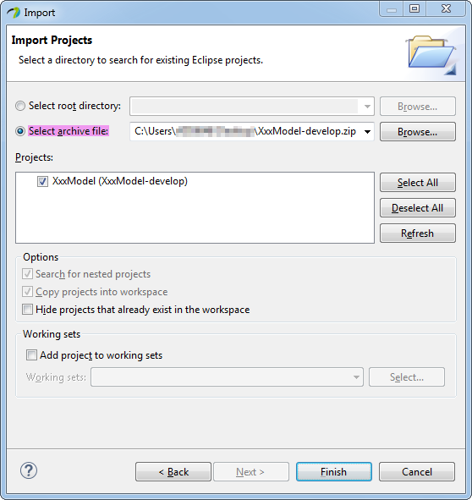

Figure 6‑37: Importing the XxxModel into Papyrus (2)

Click .

# Using Papyrus

## Illustrative Profile and Model

This guideline document uses an illustrative UML profile and an illustrative core-model and sub-model to explain the handling of Papyrus.

UML artifacts are defined by their properties (i.e., a kind of Meta Model). Standard properties are defined by the UML Specification [3] which are usually already supported by the UML tool (e.g., Papyrus). Additional specific properties are defined in a UML Profile (model).  
The UML Guidelines document [4] describes the additional properties in detail.

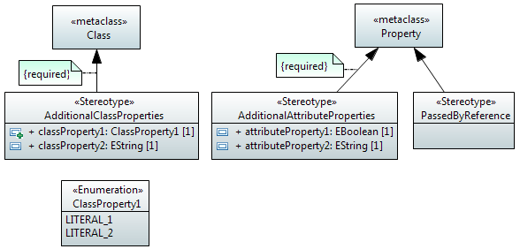

Figure 7‑1: Illustrative UML Profile

The AdditionalClassProperties stereotype adds properties classProperty1 and classProperty2 to the object classes in the model. The extension relationship has been defined as “required” which adds the additional properties to all object classes; i.e., for every class created, the AdditionalClassProperties stereotype will be present by default.

The AdditionalAttributeProperties stereotype adds properties attributeProperty1 and attributeProperty2 to the attributes in the model. The extension relationship has been defined as “required”, which adds the additional properties to all attributes; i.e., for every attribute created, the AdditionalAttributeProperties stereotype will be present by default.

The PassedByReference stereotype identifies an attribute or an operation parameter being passed by value or passed by reference. The extension relationship has not been defined as “required”, which means that the stereotype has to be associated to the attribute on a case by case basis.  
Note:  
Only those attributes and operation parameters that refer to object classes may have the PassedByReference stereotype.

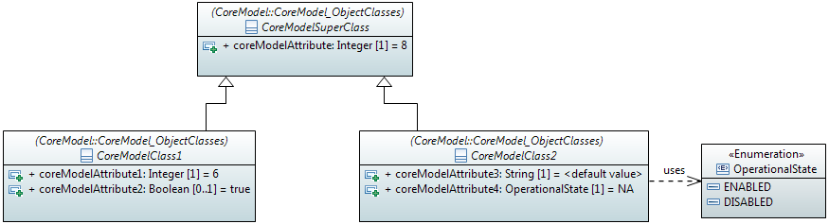

Figure 7‑2: Illustrative Core Model

The initial core model contains a super-class and two sub-classes.

The profile from Figure 7‑1 is associated to the model. This adds the additional properties to the artifacts in the model or allows their use in the model respectively.

It is possible to check if a profile is associated to the model (and which one) by clicking on  inside the  and then click the  tab of the  view.

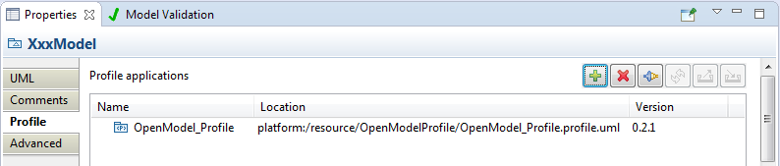

Figure 7‑3: Profile Associated to the Model

## Papyrus File Structure

A Papyrus model is stored in three different files (.di, .notation, .uml):

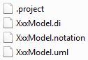 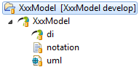

(Structure on the file system (left side); structure in the Papyrus Project Explorer (right side))

Figure 7‑4: Papyrus File Structure

As already mentioned in clause 5.3, a model cannot exist on its own in Papyrus. It has to be contained by a “project”. A project can contain many models (i.e., multiple sets of .di, .notation, .uml files, as shown in Figure 7‑5 below). The .project file contains the information about the project.

## Model Splitting

Papyrus is able to split a UML model into different pieces (i.e., different files) allowing various teams to develop the model in a collaborative manner. The model pieces can be edited independently of the core model and then be re-merged with the core model.

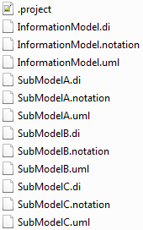 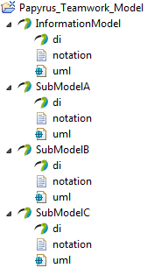

(Structure on the file system (left side); structure in the Papyrus Project Explorer (right side))

Figure 7‑5: Papyrus File Structure after Splitting

Each sub-model designer will be provided with all profile and model files to allow a comprehensive view (including cross-associations) on the Information Model at a given time of specification. Only the own sub-model files (.di, .notation, .uml) are writeable; all other files are write protected.

 Write protected files shall not be changed.   
Changes in the other parts of the model are only allowed by the respective model designer.

The sub-model designer shall be able to relate the sub-model object classes to the core object classes and to use the data types defined in the common data types library.  
This is enabled by importing the core-model object classes and core-model type definitions into the sub-model. The common UML Primitive Types (i.e., Boolean, Integer, String) also need to be imported. Clause 6.4 (step 6.4.4) explains how to import additional artefacts.

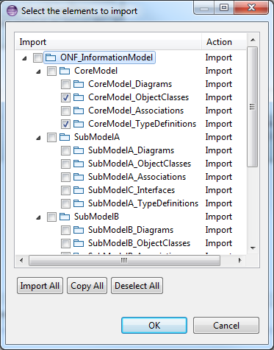 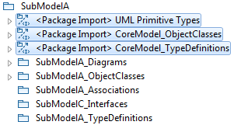

Figure 7‑6: Imported UML Artifacts

Note:  
In case one sub-model needs to refer to object classes or type definitions from another sub-model, these artifacts also need to be imported into the sub-model. In case such a definition is used in more than one other sub-model, the definition should be “elevated” to the core-model.

## Constructing Modeling Environment for a new Model

This clause describes the prerequisites that have to be configured in order to define a new model.  
The following steps need to be executed:

1. Download model infrastructure files (CommonDataTypes, StyleSheets, Open Model Profiles) from Github
2. Create a new model in a new project
3. Copy downloaded model infrastructure files into new project
4. Apply the Open Model Profiles to the new model
5. Create Default Packages
6. Add the style sheet to the new model
7. Load CommonDataTypes libraries into the new model



Figure 7‑7: Building Modeling Infrastructure

### Download model infrastructure files (CommonDataTypes, StyleSheets, Open Model Profiles) from Github

See clause 6.2: Steps 0 - 6.2.3.

After step 3 the  should have this state:



Figure 7‑8: Downloaded Model Infrastructure Files

### Create a new model in a new project

Right click in the  area and select New, :

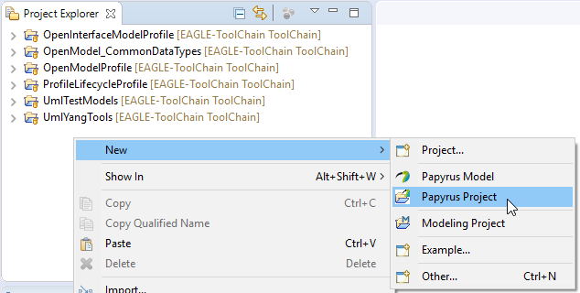

Figure 7‑9: Creating a new Papyrus Project (1)

Select :

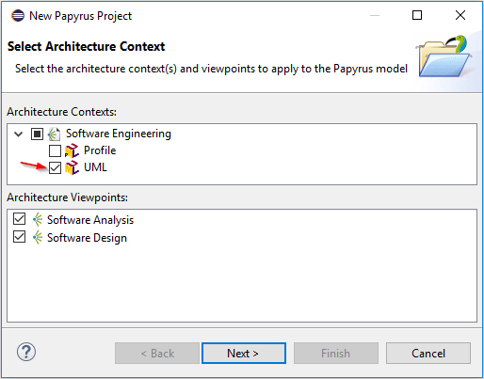

Figure 7‑10: Creating a new Papyrus Project (2)

Click , enter the project name and the model file name.

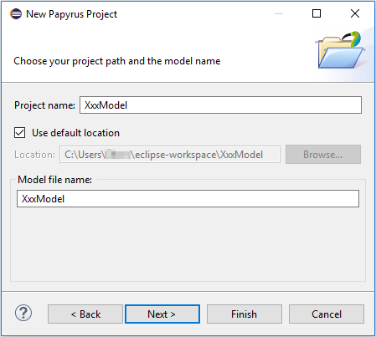

Figure 7‑11: Creating a new Papyrus Project (3)

Click , enter the root model name and check  which makes

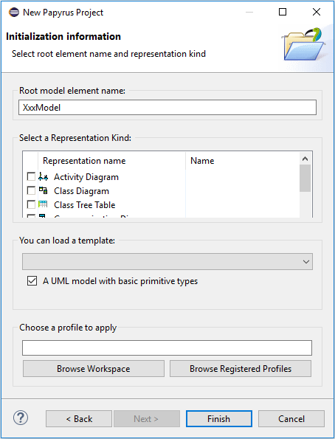

Figure 7‑12: Creating a new Papyrus Project (4)

Click .

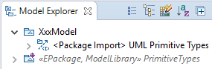

Figure 7‑13: Creating a new Papyrus Project (5)

### Copy downloaded model infrastructure files into new project

 The model infrastructure files need to be copied into the new project,  to allow that different models in a workspace use different versions of the files.

The easiest way is to copy&paste the downloaded files directly using the Windows-Explorer (i.e., outside Papyrus).

Copy the  and  folders from the downloaded EAGLE-ToolChain branch located in the git folder:

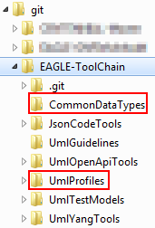

Figure 7‑14: CommonDataTypes and UMLProfiles Folders on Local PC

Paste the  and  folders into the XxxModel folder in the workspace:

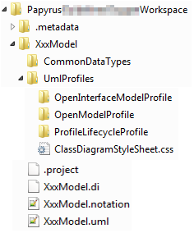

Figure 7‑15: CommonDataTypes and UMLProfiles Folders pasted to Model Folder

Delete the .project files from the inserted folders:

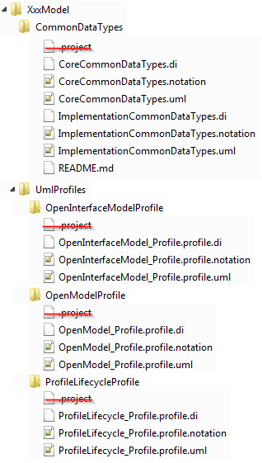

Figure 7‑16: .project Files to be deleted from the Folders

Refresh the XxxModel in the  of Papyrus to make the model infrastructure folders visible.

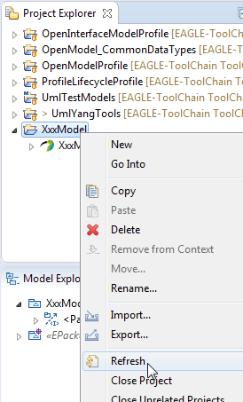 🡪 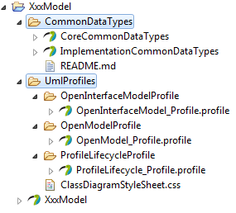

Figure 7‑17: Model Infrastructure Files in XxxModel Project

### Apply the Open Model Profiles to the new model

Select  in the , then select the Profile tab in  and click on the Apply profile button :

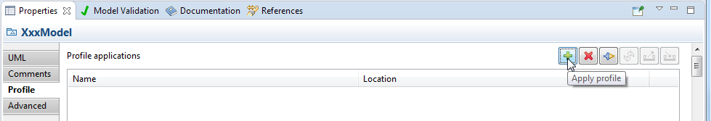

Figure 7‑18: Applying Profiles (1)

Identify the three profiles and click :

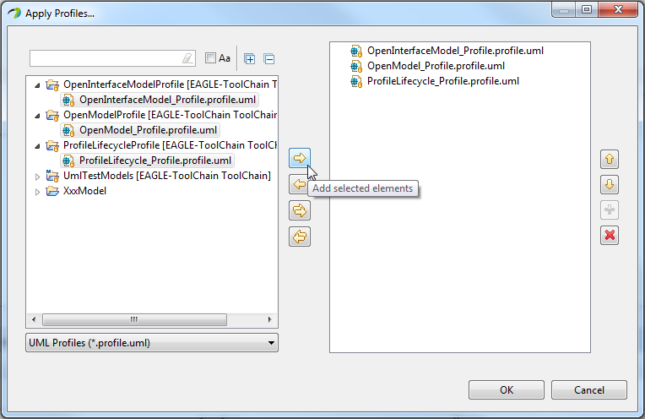

Figure 7‑19: Applying Profiles (2)

Select all profiles and click :

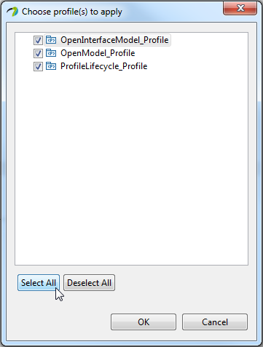

Figure 7‑20: Applying Profiles (3)

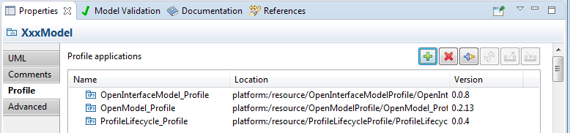

Figure 7‑21: Profiles Applied

### Create Default Packages

In order to reduce clutter, the UML artefacts are grouped in packages instead of having all kinds of the various artefacts mashed up at the same level. This provides a human friendly structure for the model. This structure accelerates the manual search for specific kinds of artefacts.

Right click on  and add all required default packages via New Child and :

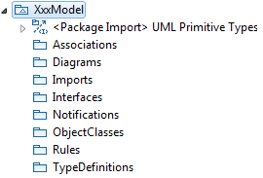

Figure 7‑22: Default Package Structure

### Add the Style Sheet to the new model

Create a class diagram in the  package via:

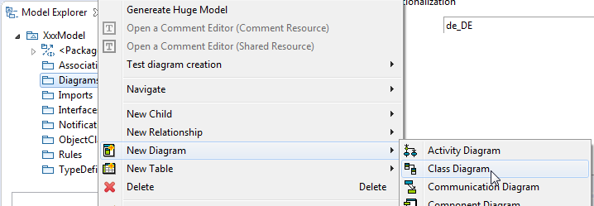

Figure 7‑23: Creating a Class Diagram

Select the created  in the , then select the Style tab in  and click on the Add elements button  of the **Model** style sheets box:

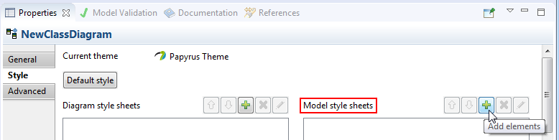

Figure 7‑24: Adding Class Diagram Style Sheet (1)

Note: This guideline describes how to assign the style sheet to all diagrams in the model. It is also possible to assign a style sheet to an individual class diagram by clicking on the Add elements button  of the **Diagram** style sheets box.

Click the Create a new element button , select :

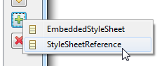

Figure 7‑25: Adding Class Diagram Style Sheet (2)

Click  and select  file in the XxxModel:

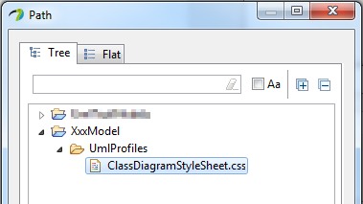

Figure 7‑26: Adding Class Diagram Style Sheet (3)

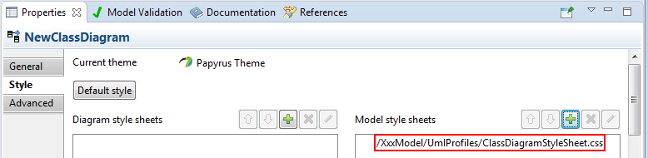

Figure 7‑27: Adding Class Diagram Style Sheet (4)

### Load CommonDataTypes libraries into the new model

Right-click on the model package , select  and then :

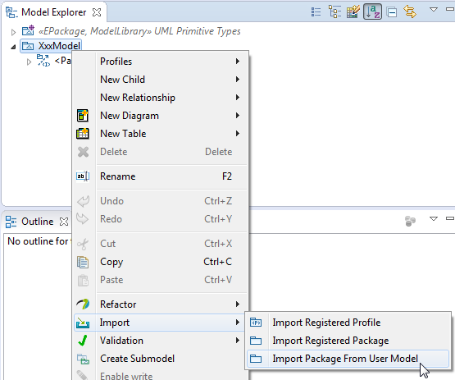

Figure 7‑28: Loading CommonDataTypes Libraries (1)

Expand and , select  and  and add them :

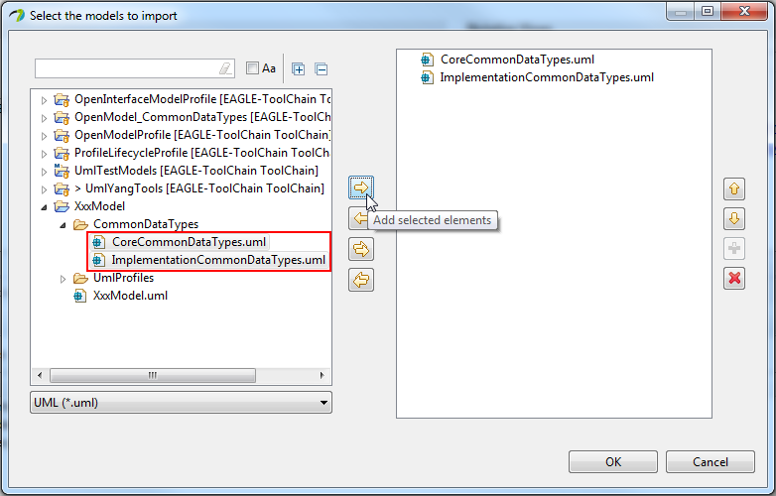

Figure 7‑29: Loading CommonDataTypes Libraries (2)

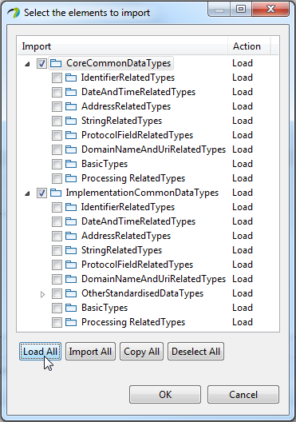

Figure 7‑30: Loading CommonDataTypes Libraries (3)

It is possible to  or just a subset of the Data Types. This is based on the requirements of the new model.

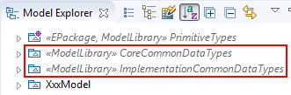

Figure 7‑31: Loading CommonDataTypes Libraries (4)

The Common Data Types are now available for use in the XxxModel.

## Tips & Tricks

### Class Diagram: Auto Size

By default, the artefacts in a class diagram are auto-sized to fit to the content. It may be necessary to manually adjust the size of an artefact (e.g., enlarge it in case the artefact box is too small for the number of associations attached to the box).  
Once you have manually changed the size of the box, the Auto-Size function is switched off for that box.  
🡪 It is possible to “switch on” again auto-sizing for a box by selecting the box, go to  in the Menu-Bar, click on  and select :

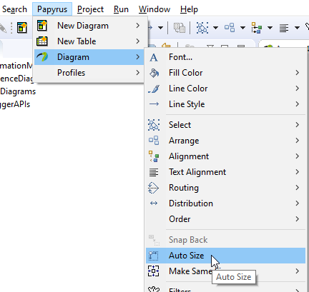

Figure 7‑32: Auto Size Function

### Class Diagram: Display Signals/Notifications defined inside an Object Class

A UML Signal (Notification) that is defined inside an object class can be displayed in a class diagram by making the “nested classifiers” compartment visible. This can be done by checking the “nested classifiers” compartment in the  window (Ctrl + F5).

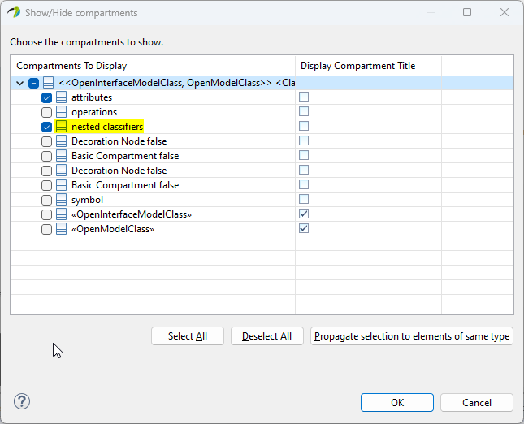 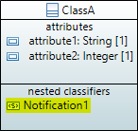

Figure 7‑33: Display “nested classifiers” Compartment

Note: Don’t forget to check the Notification in the  window (F4).

# Generating Model Documentation

## Introduction

This clause describes how to extract diagrams, comments and details for a Data Dictionary from a Papyrus model using the Gendoc plugin.

Editor’s notes:  
This clause is still a draft and will likely be changed in future versions.  
Please check the known issues in clause 8.17 for any limitation which exists at the time.

A basic document generation tutorial is available at  
https://www.eclipse.org/gendoc/documentation/Gendoc_v0.6_tutorial.pdf. This provides detail in some areas but does not cover all aspects of usage. The following subclauses provide further guidance along with template fragments to assist understanding. A template that generates a normal form of model documentation is included for a dummy model.

Gendoc works with Microsoft Word and the template is a Word file. The template can be a mix of Gendoc script, normal text, Word figures, tables etc. Thus, if a word document with other non-model related information shall be created, but then have a clause specifically for the model, insert the “gendoc” related information as part of that Word document. The following clause builds up a template from the basic framing script through to a full template. The target document resulting from the gendoc template:

* Is produced in a form that can be published having all the necessary cover material, table of contents, headers, footers etc
* Contains specific figures extracted from the model in a specific with additional interleaved description and word figures
* Contains a data dictionary clause

The template described does not:

* Take advantage of the package structure of the model
* Interleave class description text with figures
  + Instead the figures refer to the data dictionary clause for formal description and structure

It should be noted that at the time of writing this clause there are a number of know issues with Gendoc (highlighted at the end of this clause).

## Template usage

The template is stored in a system folder accessible via an Eclipse project so that the template can be seen in the Papyrus Project Explorer. The folder could be a sub-folder of the system folder containing the project that includes the model to be documented. Alternatively, the template can be stored in a specific project that just includes the template. The template “points” to the model to be extracted via the <context model> statement. The template is highlighted with the right-click menu and the “Generate documentation using Gendoc” item is selected. This will run the template, i.e. Gendoc is initiated from the template NOT from the model.

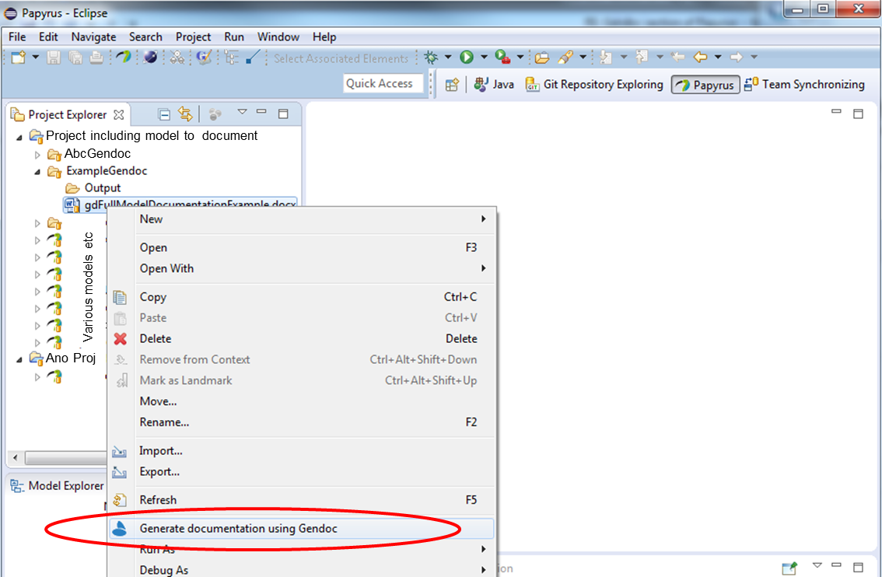

Figure 8‑1: Initiating Gendoc for a particular template

The following clause explain how the template is targeted at the desired model.

## Basic template

The template includes the name of the model to be documented and the name of the target model (substitute path and model name in the structure below). Both the .uml and .notation files are required.[3]

<config>  
<output path=’C:\Users\---appropriate path name--\ModelOutput.docx' />

</config>

<context model=’C:\Users\---appropriate path name--\ModelName.notation' element=’{0}’ importedBundles='gmf;papyrus' />

<gendoc><drop/>

Provides access to diagrams

</gendoc><drop/>

<context model=’C:\Users\---appropriate path name--\ModelName.uml' element=’{0}’ importedBundles='gmf;papyrus' />

<gendoc><drop/>

Provides access to class details

</gendoc><drop/>

This particular template produces a document with the two black text items only. In the above example, the entire model “ModelName.uml” is taken as input. In order to select only one package in the model, one would set “element=’ModelName/{package name}’”.

## Cover, contents, closing text etc

Any text and figures[4] inserted between the <gendoc> to </gendoc> space will be produced in the output.

<gendoc><drop/>

Any text and diagrams etc…

</gendoc><drop/>

## Figures from the model with interleaved text

The figures can be extracted in alphabetical order from the model. The following script (in bold) will print the figure titles from the model in alphabetical order.

<config>  
<output path=’C:\Users\---appropriate path name--\ModelOutput.docx' />

</config>

<context model=’C:\Users\---appropriate path name--\ModelName.notation' element=’{0}’ importedBundles='gmf;papyrus' />

<gendoc><drop/>

**[for (d : notation::Diagram |notation::Diagram.allInstances()->sortedBy(name))]<drop/>**

**[d.name/]**

**[/for]<drop/>**

</gendoc><drop/>

Clearly this by itself is not particularly useful but substituting the “[d.name/]” with the following bold script and replacing “specificDiagramName“ with the name (or unique substring of a name) of a diagram in the model will extract a specific named diagram (printing the diagram and its name)[5].

<gendoc><drop/>

**Text** **and figures leading to diagram …**

[for (d : notation::Diagram |notation::Diagram.allInstances()->sortedBy(name))]<drop/>

**[if d.name.contains('specificDiagramName')] [d.name/]**

**<drop/>**

**<image object='[d.getDiagram()/]' maxW='true' keepH='false' keepW=’false’></image>**

Figure 1 [d.name/]

**[else]<drop/>**

**[/if]<drop/>**

[/for]<drop/>

**More text and figures after diagram ….**

</gendoc><drop/>

The yellow area highlights a frame (which is otherwise not obvious). This frame is where Gendoc will place the figure. The frame will need to be sized to the right width in an actual usage (shrunk here to reduce space used in this document). The script will allow Gendoc to adjust the height but forces it to not exceed maximum width.

The following template extract expands for two figures (and could clearly be expanded to cover many more.

<gendoc><drop/>

**Text** **and figures leading to diagram …**

[for (d : notation::Diagram |notation::Diagram.allInstances()->sortedBy(name))]<drop/>

**[if d.name.contains('specificDiagramName')] [d.name/]**

**<drop/>**

**<image object='[d.getDiagram()/]' maxW='true' keepH='false' keepW=’false’></image>**

Figure 1 [d.name/]

**[else]<drop/>**

**[/if]<drop/>**

[/for]<drop/>

**More text and figures after diagram and leading to the second diagram**

[for (d : notation::Diagram |notation::Diagram.allInstances()->sortedBy(name))]<drop/>

**[if d.name.contains('anotherSpecificDiagramName')] [d.name/]**

**<drop/>**

**<image object='[d.getDiagram()/]' maxW='true' keepH='false' keepW=’false’></image>**

Figure 2 [d.name/]

**[else]<drop/>**

**[/if]<drop/>**

[/for]<drop/>

**More text and figures after diagram ….**

</gendoc><drop/>

The model may have many figures, the remainder will be ignored. Clearly care needs to be taken to ensure that one figure does not have a name string that is a sub-string of another name.

## Figure in alphabetical order with no interleaved specific text

Alternatively the simple loop can be used to list all figures in alphabetical order. These cannot have associated document text inserted automatically.

<config>  
<output path=’C:\Users\---appropriate path name--\ModelOutput.docx' />

</config>

<context model=’C:\Users\---appropriate path name--\ModelName.notation' element=’{0}’ importedBundles='gmf;papyrus' />

<gendoc><drop/>

**[for (d : notation::Diagram |notation::Diagram.allInstances()->sortedBy(name))]<drop/>**

**[d.name/]**

**<image object='[d.getDiagram()/]' maxW='true' keepH='false' keepW=’false’></image>**

Figure 1 [d.name/]

**[/for]<drop/>**

</gendoc><drop/>

## Further explanation of the script

A majority of the script used in the previous clauses should be relatively obvious (e.g. [for…]… [/for] loop and [if…]… [else]… [/if] nested structures. The specific contents of the for and if statements is covered adequately in the tutorial material referenced earlier. One key thing to highlight here is the use of <drop/>. This instruction causes Gendoc to not throw a line break for the line that has <drop/>. Many blank lines may be found in the output. This will normally be because one or more <drop/> instructions have been forgotten.

There is a peculiar behavior with diagrams that requires a <drop/> on the blank line prior to the <image…> command. Without this part (but not all) of the <image… > instruction is printed.

## Test template for printing diagrams and associated text

The following embedded file contains script which when modified to select the right model (several places in the file) and output locations will print three diagrams from the model.



## Data Dictionary template overview

In the following subclauses the template is extended to add data dictionary content. This particular example data dictionary includes Classes and Data Types along with their attributes and for each provides (as appropriate):

* Comments
* Properties
* Stereotypes

Note that the stereotypes examples are from the OpenModelProfile [7].

## Adding the class and its stereotypes

Considering the basic template described above and replacing the text “Provides access to class details” with the clause in bold below will provide the class name, class comments comments and the class stereotypes

<config>  
<output path=’C:\Users\---appropriate path name--\ModelOutput.docx' />

</config>

<context model=’C:\Users\---appropriate path name--\ModelName.notation' element=’{0}’ importedBundles='gmf;papyrus' />

<gendoc><drop/>

Provides access to diagrams

</gendoc><drop/>

<context model=’C:\Users\---appropriate path name--\ModelName.uml' element=’{0}’ importedBundles='gmf;papyrus' />

<gendoc><drop/>

**[for (cl:Class | Class.allInstances()->sortedBy(name))]<drop/>**

**[cl.name/]**

**[for (co:Comment | cl.ownedComment)]<drop/>**

**<dropEmpty>[co._body.clean()/]</dropEmpty>**

**[/for]<drop/>**

**Applied stereotypes:**

**[for (st:Stereotype | cl.getAppliedStereotypes())]<drop/>**

* **[st.name/]**

**[for (oa:Property|st.ownedAttribute)]<drop/>**

* **[if (not oa.name.contains('base'))][oa.name/]: [if (not cl.getValue(st, oa.name).oclIsUndefined())][if oa.name.contains('condition')][cl.getValue(st, oa.name).oclAsType(String)/] [else][cl.getValue(st, oa.name).oclAsType(EnumerationLiteral).name/][/if][else]<drop/>[/if]**

**[/if] <drop/>**

**[/for]<drop/>**

**[/for]<drop/>**

**[/for]<drop/>**

</gendoc><drop/>

Note that:

* The classes are in alphabetical order
* The comment body is not printed if empty using the <dropEmpty>..</dropEmpty> instruction
* Any properties of stereotypes that have “base” in their name are not printed
* “conditions” are only printed if there is a specified condition
* The [cl.name/] would be expected to be a heading in a normal document

## Adding properties and stereotypes in tabular form

The script from the previous clause has been extended with the additional script highlighted below in bold (other than the table contents). The table produced by the script here includes an explicit structuring of the stereotypes.

<config>  
<output path=’C:\Users\---appropriate path name--\ModelOutput.docx' />

</config>

<context model=’C:\Users\---appropriate path name--\ModelName.notation' element=’{0}’ importedBundles='gmf;papyrus' />

<gendoc><drop/>

Provides access to diagrams

</gendoc><drop/>

<context model=’C:\Users\---appropriate path name--\ModelName.uml' element=’{0}’ importedBundles='gmf;papyrus' />

<gendoc><drop/>

[for (cl:Class | Class.allInstances()->sortedBy(name))]<drop/>

[cl.name/]

[for (co:Comment | cl.ownedComment)]<drop/>

<dropEmpty>[co._body.clean()/]</dropEmpty>

[/for]<drop/>

Applied stereotypes:

[for (st:Stereotype | cl.getAppliedStereotypes())]<drop/>

* [st.name/]

[for (oa:Property|st.ownedAttribute)]<drop/>

* [if (not oa.name.contains('base'))][oa.name/]: [if (not cl.getValue(st, oa.name).oclIsUndefined())][if oa.name.contains('condition')][cl.getValue(st, oa.name).oclAsType(String)/] [else][cl.getValue(st, oa.name).oclAsType(EnumerationLiteral).name/][/if][else]<drop/>[/if]

[/if] <drop/>

[/for]<drop/>

[/for]<drop/>

**[if cl.ownedAttribute->notEmpty()]<drop/>**

**Table 1: Attributes for [cl.name/]**

**<drop/>**

**<table><drop/>**

|  |  |  |  |  |  |
| --- | --- | --- | --- | --- | --- |
| **Attribute Name** | **Type** | **Multiplicity** | **Access** | **Stereotypes** | **Description** |

**[for (p:Property|cl.ownedAttribute)]<drop/>**

|  |  |  |  |  |  |
| --- | --- | --- | --- | --- | --- |
| **[p.name/]** | **[p.type.name/]** | **[if(p.lower=p.upper)]1[else][p.lower/]..[if(p.upper=-1)]*[else][p.upper/][/if][/if]** | **[if(not(p.isReadOnly))]RW[else]R[/if]** | **[for (st:Stereotype | p.getAppliedStereotypes())]<drop/>**  **[st.name/]**  **[for(oa:Property|st.ownedAttribute)]<drop/>**   * **[if oa.name.contains('attribute')]AVC: [p.getValue(st, oa.name).oclAsType(EnumerationLiteral).name/]**   **[else]<drop/>**   * **[if oa.name.contains('invariant')]isInvariant: [p.getValue(st, oa.name).oclAsType(Boolean)/]**   **[else]<drop/>**   * **[if oa.name.contains('value')]valueRange: [if (not p.getValue(st, oa.name).oclIsUndefined())][p.getValue(st, oa.name).oclAsType(String)/][else] no range constraint [/if]**   **[else]<drop/>**   * **[if oa.name.contains('support')]support: [p.getValue(st, oa.name).oclAsType(EnumerationLiteral).name/]**   **[else]<drop/>**   * **[if oa.name.contains('condition')][if (not p.getValue(st, oa.name).oclIsUndefined())]condition:[p.getValue(st, oa.name).oclAsType(String)/][else] <drop/> [/if]**   **[else]<drop/>**  **[/if]<drop/>**  **[/if]<drop/>**  **[/if]<drop/>**  **[/if]<drop/>**  **[/if]<drop/>**  **[/for]<drop/>**  **[/for]<drop/>** | **[for (c:Comment | p.ownedComment)] <drop/>**  **[c._body.clean()/]**  **[/for]** |

**[/for]<drop/>**

**</table><drop/>**

**[else][/if]<drop/>**

[/for]<drop/>

</gendoc><drop/>

Note that this and following clauses have been reoriented to landscape as is advisable in a document when producing attribute data dictionary content.

## Adding complex data types

A complex data types have a very similar structure to a class and hence the Gendoc commands are similar. The following snippet highlights in bold the differences between the class script above and the data type script replacing from “[for (cl:Class | Class.allInstances()->sortedBy(name))]<drop/>”

[for **(dt:DataType | DataType.**allInstances()->sortedBy(name))]<drop/>

[if **dt.**oclIsTypeOf**(DataType)**]<drop/>

[**dt**.name/]

[for (co:Comment | **dt.**ownedComment)]<drop/>

<dropEmpty>[co._body.clean()/]</dropEmpty>

[/for]<drop/>

Applied Stereotypes:

**[for (st:Stereotype | dt.getAppliedStereotypes())]<drop/>**

* **[st.name/]**

**[/for]<drop/>**

[if **dt**.ownedAttribute->notEmpty()]<drop/>

Table 2: Attributes for [dt.name/]

<drop/>

<table><drop/>

|  |  |  |  |  |  |
| --- | --- | --- | --- | --- | --- |
| **Attribute Name** | **Type** | **Multiplicity** | **Access** | **Stereotypes** | **Description** |

[for (p:Property|dt.ownedAttribute)]<drop/>

…… then the table is the same as for the class attributes…

## Adding other data types

### Enumeration Types

The following script will extract all enumerations with their comments and list the literals with their comments for each. Clearly stereotypes can be extracted using fragments of script from earlier clauses.

[for (dt:DataType | DataType.allInstances()->sortedBy(name))]<drop/>

[if dt.oclIsTypeOf(Enumeration)]<drop/>

[dt.name/]

[for (co:Comment | dt.ownedComment)]<drop/>

<dropEmpty>[co._body.clean()/]</dropEmpty>

[/for]<drop/>

Contains Enumeration Literals:

[for (e:EnumerationLiteral|dt.oclAsType(Enumeration).ownedLiteral)]<drop/>

* [e.name/]:
  + [for (co:Comment | e.ownedComment)]<drop/>
  + <dropEmpty>[co._body.clean()/]
  + </dropEmpty>[/for]<drop/>

[/for]<drop/>

[else] [/if]<drop/>

[/for]<drop/>

### Primitive Types

Primitive types can be listed with comments using the followings script.

[for (dt:DataType | DataType.allInstances()->sortedBy(name))]<drop/>

[if dt.oclIsTypeOf(PrimitiveType)]<drop/>

[dt.name/]

[for (co:Comment | dt.ownedComment)]<drop/>

<dropEmpty>[co._body.clean()/]</dropEmpty>

[/for]<drop/>

[else] [/if]<drop/>

[/for]<drop/>

## Adding «ExtendedComposite» associations

«ExtendedComposite» associations can be listed with comments using the followings script.

## Using Fragments

### Fragment Definitions

#### Introduction

Gendoc provides the capability of reusing Gendoc scripts inside the same document by defining subroutines called “fragments”. It is possible to instruct the subroutines using transfer parameters.

The following clauses contain pre-defined fragments.

#### Insert Class Fragment

<fragment name=’insertClass’ importedBundles=’commons;gmf;papyrus’><drop/>  
<arg name=’cl’ type=’uml::Class’/><drop/>  
<arg name=’className’ type=’String’/><drop/>  
<arg name=’packageName’ type=’String’/><drop/>  
[if (not cl.qualifiedName.contains(packageName))]<drop/>  
[else] <drop/>  
[if(cl.name.contains(className))]<drop/>

Qualified Name: [cl.qualifiedName/]

[for (co:Comment | cl.ownedComment)]<drop/>

<dropEmpty>[co._body.clean()/]</dropEmpty>

[/for]<drop/>  
[cl.displayConstraints()/]<drop/>  
[for (st:Stereotype | cl.getAppliedStereotypes())]<drop/>  
[if(not st.name.contains(‘OpenModelClass’))]<drop/>

This class is [st.name/].

[else] <drop/>  
[/if]<drop/>  
[/for]<drop/>  
[else] <drop/>  
[/if]  
[/if]  
</fragment><drop/>

#### Insert Standard Diagram Fragment

<fragment name=’insertStandardDiagram’ importedBundles=’commons;gmf;papyrus’><drop/>  
<arg name=’p’ type=’uml::Package’/><drop/>  
<arg name=’diagramName’ type=’String’/><drop/>  
<arg name=’diagramTitle’ type=’String’/><drop/>

[for (d:Diagram|p.getPapyrusDiagrams())]<drop/>

[if d.name.contains(diagramName)]

<drop/>

<image object='[d.getDiagram()/]' maxW='true' keepH='false' keepW = ‘false’></image>

Figure 8-2 [diagramTitle/]

CoreModel diagram: [d.name/]

[else]<drop/>

[/if]<drop/>

[/for]<drop/>  
</fragment><drop/>

#### Insert Small Diagram Fragment

<fragment name=’insertSmallDiagram’ importedBundles=’commons;gmf;papyrus’><drop/>  
<arg name=’p’ type=’uml::Package’/><drop/>  
<arg name=’diagramName’ type=’String’/><drop/>  
<arg name=’diagramTitle’ type=’String’/><drop/>

[for (d:Diagram|p.getPapyrusDiagrams())]<drop/>

[if d.name.contains(diagramName)]

<drop/>

<image object='[d.getDiagram()/]' maxW='true' keepH='false' keepW = ‘false’></image>

Figure 8-3 [diagramTitle/]

CoreModel diagram: [d.name/]

[else]<drop/>

[/if]<drop/>

[/for]<drop/>  
</fragment><drop/>

#### Insert Attribute Row Brief Fragment

<fragment name=’insertAttributeRowBrief’ importedBundles=’commons;gmf;papyrus’><drop/>  
<arg name=’p’ type=’uml::Property’/><drop/>

|  |  |  |
| --- | --- | --- |
| [p.name/] | [for (st:Stereotype | p.getAppliedStereotypes())]<drop/>  [if(not st.name.contains(‘OpenModelAttribute’))] [st.name/]  [/if]<drop/>  [/for]<drop/> | [if p.ownedComment->notEmpty()]<drop/>  [for (c:Comment | p.ownedComment)] <drop/>  [c._body.clean()/]  [/for]  [else] [if (p.name.contains (‘_’))] See referenced class  [else] NO DESCRIPTION  [/if]<drop/>  [/if]<drop/> |

</fragment><drop/>

#### Start Attribute Table Brief Fragment

<fragment name=’insertAttributeTableHeader’ importedBundles=’commons;gmf;papyrus’><drop/>  
<arg name=’cl’ type=’uml::Class’/><drop/>

|  |  |  |
| --- | --- | --- |
| **Attribute Name** | **Lifecycle Stereotype (empty = Mature)** | **Description** |

</fragment><drop/>

#### Insert Attribute Table Brief Fragment

<fragment name=’insertAttributeTableBrief’ importedBundles=’commons;gmf;papyrus’ importedFragments='insertAttributeTableHeader;insertAttributeRowBrief’><drop/>  
<arg name=’cl’ type=’uml::Class’/><drop/>  
[if cl.ownedAttribute->notEmpty()]<drop/>

Table 3: Attributes for [cl.name/]

<table><drop/>

[cl.insertAttributeTableHeader ()/]

[for (p:Property|cl.ownedAttribute)]<drop/>

[if (not p.name.contains(‘_’))]<drop/>

[p.insertAttributeRowBrief ()/]

[/if]<drop/>

[/for]<drop/>

[for (p:Property|cl.ownedAttribute)]<drop/>

[if (p.name.contains(‘_’))]<drop/>

[p.insertAttributeRowBrief ()/]

[/if]<drop/>

[/for]<drop/>

</table><drop/>

[/if]<drop/>

</fragment><drop/>

#### Insert Ten Specified Attribute Table Brief Fragment

<fragment name=’insertTenSpecifiedAttributeTableBrief’ importedBundles=’commons;gmf;papyrus’ importedFragments='insertAttributeTableHeader;insertAttributeRowBrief’><drop/>  
<arg name=’cl’ type=’uml::Class’/><drop/>

<arg name=’p1’ type=‘String’/><drop/>

<arg name=’p2’ type=‘String’/><drop/>  
<arg name=’p3’ type=‘String’/><drop/>  
<arg name=’p4’ type=‘String’/><drop/>  
<arg name=’p5’ type=‘String’/><drop/>  
<arg name=’p6’ type=‘String’/><drop/>  
<arg name=’p7’ type=‘String’/><drop/>  
<arg name=’p8’ type=‘String’/><drop/>  
<arg name=’p9’ type=‘String’/><drop/>  
<arg name=’p10’ type=‘String’/><drop/>  
[if cl.ownedAttribute->notEmpty()]<drop/>

Table 4: Attributes for [cl.name/]

<table><drop/>

[cl.insertAttributeTableHeader ()/]

[for (p:Property|cl.ownedAttribute)]<drop/>

[if (p.name.contains(p1) or p.name.contains(p2) or p.name.contains(p3) or p.name.contains(p4) or p.name.contains(p5) or p.name.contains(p6) or p.name.contains(p7) or p.name.contains(p8) or p.name.contains(p9) or p.name.contains(p10))]<drop/>

[if (not p.name.contains(‘_’))]<drop/>

[p.insertAttributeRowBrief ()/]

[/if]<drop/>

[/if]<drop/>

[if (p.name.contains(p1) or p.name.contains(p2) or p.name.contains(p3) or p.name.contains(p4) or p.name.contains(p5) or p.name.contains(p6) or p.name.contains(p7) or p.name.contains(p8) or p.name.contains(p9) or p.name.contains(p10))]<drop/>

[if (p.name.contains(‘_’))]<drop/>

[p.insertAttributeRowBrief ()/]

[/if]<drop/>

[/if]<drop/>

[/for]<drop/>

</table><drop/>

[/if]<drop/>

</fragment><drop/>

#### Insert Data Type Fragment

<fragment name=’insertDataType’ importedBundles=’commons;gmf;papyrus’><drop/>  
<arg name=’dt’ type=’uml::DataType’/><drop/>  
<arg name=’dataTypeName’ type=’String’/><drop/>  
<arg name=’packageName’ type=’String’/><drop/>  
[if (dt.qualifiedName.contains(packageName))]<drop/>  
[if(dt.name.contains(dataTypeName))]<drop/>

Qualified Name: [dt.qualifiedName/]

[for (co:Comment | dt.ownedComment)]<drop/>

<dropEmpty>[co._body.clean()/]</dropEmpty>

[/for]<drop/>  
[dt.displayConstraints()/]<drop/>  
[for (st:Stereotype | dt.getAppliedStereotypes())]<drop/>  
This class is [st.name/].

[/for]<drop/>  
[else] <drop/>  
[/if]  
[/if]  
</fragment><drop/>

#### Start Data Type Attribute Table Brief Fragment

<fragment name=’insertDataTypeAttributeTableHeader’ importedBundles=’commons;gmf;papyrus’><drop/>  
<arg name=’dt’ type=’uml::DataType’/><drop/>

|  |  |  |
| --- | --- | --- |
| **Attribute Name** | **Lifecycle Stereotype (empty = Mature)** | **Description** |

</fragment><drop/>

#### Insert Data Type Attribute Table Brief Fragment

<fragment name=’insertDataTypeAttributeTableBrief’ importedBundles=’commons;gmf;papyrus’ importedFragments='insertDataTypeAttributeTableHeader;insertAttributeRowBrief’><drop/>  
<arg name=’dt’ type=’uml::DataType’/><drop/>  
[if dt.ownedAttribute->notEmpty()]<drop/>

Table 5: Attributes for [dt.name/]

<table><drop/>

[dt.insertDataTypeAttributeTableHeader ()/]

[for (p:Property|dt.ownedAttribute)]<drop/>

[p.insertAttributeRowBrief ()/]

[/for]<drop/>

</table><drop/>

[/if]<drop/>

</fragment><drop/>

#### Insert Classes (DD only) Fragment

<fragment name=’insertClasses’ importedBundles=’commons;gmf;papyrus’><drop/>  
<arg name=’cl’ type=’uml::Class’/><drop/>

**<Word section heading> [cl.name/]**

Qualified Name: [cl.qualifiedName/]

[for (co:Comment | cl.ownedComment)]<drop/>

<dropEmpty>[co._body.clean()/]</dropEmpty>

[/for]<drop/>

Applied stereotypes:

[for (st:Stereotype | cl.getAppliedStereotypes())]<drop/>

* [st.name/]

[for (oa:Property|st.ownedAttribute)]<drop/>

* [if (not oa.name.contains('base'))][oa.name/]: [if (not cl.getValue(st, oa.name).oclIsUndefined())][if oa.name.contains('condition')][cl.getValue(st, oa.name).oclAsType(String)/] [else][cl.getValue(st, oa.name).oclAsType(EnumerationLiteral).name/][/if][else]<drop/>[/if]

[/if] <drop/>

[/for]<drop/>

[/for]<drop/>

[if cl.ownedAttribute->notEmpty()]<drop/>

<drop/>

Table 6: Attributes for [cl.name/]

<table><drop/>

|  |  |  |  |  |  |
| --- | --- | --- | --- | --- | --- |
| **Attribute Name** | **Type** | **Multiplicity** | **Access** | **Stereotypes** | **Description** |

[for (p:Property|cl.allAttributes())]<drop/>

| [p.name/]  [if(not p.qualifiedName.contains(cl.name))]Inherited[/if] | [p.type.name/] | [if(p.lower=p.upper)]1[else][p.lower/]..[if(p.upper=-1)]*[else][p.upper/][/if][/if] | [if(not(p.isReadOnly))]RW[else]R[/if] | [for (st:Stereotype | p.getAppliedStereotypes())]<drop/>  [st.name/]  [for(oa:Property|st.ownedAttribute)]<drop/>   * [if oa.name.contains('key')]partOfObjectKey: [p.getValue(st, oa.name).oclAsType(Integer)/]   [else]<drop/>   * [if oa.name.contains('attribute')]AVC: [p.getValue(st, oa.name).oclAsType(EnumerationLiteral).name/]   [else]<drop/>   * [if oa.name.contains('invariant')]isInvariant: [p.getValue(st, oa.name).oclAsType(Boolean)/]   [else]<drop/>   * [if oa.name.contains('value')]valueRange: [if (not p.getValue(st, oa.name).oclIsUndefined())][p.getValue(st, oa.name).oclAsType(String)/][else] no range constraint [/if]   [else]<drop/>   * [if oa.name.contains('length')]bitLength: [p.getValue(st, oa.name).oclAsType(EnumerationLiteral).name/]   [else]<drop/>   * [if oa.name.contains('unsigned')]unsigned: [p.getValue(st, oa.name).oclAsType(Boolean)/]   [else]<drop/>   * [if oa.name.contains('encoding')]encoding: [p.getValue(st, oa.name).oclAsType(EnumerationLiteral).name/]   [else]<drop/>   * [if oa.name.contains('counter')]counter: [p.getValue(st, oa.name).oclAsType(EnumerationLiteral).name/]   [else]<drop/>   * [if oa.name.contains('unit')]unit: [if (not p.getValue(st, oa.name).oclIsUndefined())][p.getValue(st, oa.name).oclAsType(String)/][else] no unit defined [/if]   [else]<drop/>   * [if oa.name.contains('support')]support: [p.getValue(st, oa.name).oclAsType(EnumerationLiteral).name/]   [else]<drop/>   * [if oa.name.contains('condition')][if (not p.getValue(st, oa.name).oclIsUndefined())]condition:[p.getValue(st, oa.name).oclAsType(String)/][else] <drop/> [/if]   [else]<drop/>  [/if]<drop/>  [/if]<drop/>  [/if]<drop/>  [/if]<drop/>  [/if]<drop/>  [/if]<drop/>  [/if]<drop/>  [/if]<drop/>  [/if]<drop/>  [/if]<drop/>  [/if]<drop/>  [/for]<drop/>  [/for]<drop/> | [if p.ownedComment->notEmpty()]<drop/>  [for (c:Comment | p.ownedComment)] <drop/>  [c._body.clean()/]  [/for]  [else] [if (p.name.contains (‘_’))] See referenced class  [else] NO DESCRIPTION  [/if]<drop/>  [/if]<drop/> |
| --- | --- | --- | --- | --- | --- |

[/for]<drop/>

</table><drop/>

[else][/if]<drop/>

</fragment><drop/>

#### Insert Data Types Fragment (DD only)

<fragment name=’insertDataTypes’ importedBundles=’commons;gmf;papyrus’><drop/>  
<arg name=’dt’ type=’uml::DataType’/><drop/>

**<Word section heading> [dt.name/]**

Qualified Name: [dt.qualifiedName/]

[for (co:Comment | dt.ownedComment)]<drop/>

<dropEmpty>[co._body.clean()/]</dropEmpty>

[/for]<drop/>

[dt.displayConstraints()/]<drop/>  
Applied stereotypes:

[for (st:Stereotype | dt.getAppliedStereotypes())]<drop/>

* [st.name/]

[/for]<drop/>

[if dt.ownedAttribute->notEmpty()]<drop/>

<drop/>

Table 7: Attributes for [dt.name/]

<table><drop/>

|  |  |  |  |  |  |
| --- | --- | --- | --- | --- | --- |
| **Attribute Name** | **Type** | **Multiplicity** | **Access** | **Stereotypes** | **Description** |

[for (p:Property|dt.ownedAttribute)]<drop/>

| [p.name/] | [p.type.name/] | [if(p.lower=p.upper)]1[else][p.lower/]..[if(p.upper=-1)]*[else][p.upper/][/if][/if] | [if(not(p.isReadOnly))]RW[else]R[/if] | [for (st:Stereotype | p.getAppliedStereotypes())]<drop/>  [st.name/]  [for(oa:Property|st.ownedAttribute)]<drop/>   * [if oa.name.contains('key')]partOfObjectKey: [p.getValue(st, oa.name).oclAsType(Integer)/]   [else]<drop/>   * [if oa.name.contains('attribute')]AVC: [p.getValue(st, oa.name).oclAsType(EnumerationLiteral).name/]   [else]<drop/>   * [if oa.name.contains('invariant')]isInvariant: [p.getValue(st, oa.name).oclAsType(Boolean)/]   [else]<drop/>   * [if oa.name.contains('value')]valueRange: [if (not p.getValue(st, oa.name).oclIsUndefined())][p.getValue(st, oa.name).oclAsType(String)/][else] no range constraint [/if]   [else]<drop/>   * [if oa.name.contains('length')]bitLength: [p.getValue(st, oa.name).oclAsType(EnumerationLiteral).name/]   [else]<drop/>   * [if oa.name.contains('unsigned')]unsigned: [p.getValue(st, oa.name).oclAsType(Boolean)/]   [else]<drop/>   * [if oa.name.contains('encoding')]encoding: [p.getValue(st, oa.name).oclAsType(EnumerationLiteral).name/]   [else]<drop/>   * [if oa.name.contains('counter')]counter: [p.getValue(st, oa.name).oclAsType(EnumerationLiteral).name/]   [else]<drop/>   * [if oa.name.contains('unit')]unit: [if (not p.getValue(st, oa.name).oclIsUndefined())][p.getValue(st, oa.name).oclAsType(String)/][else] no unit defined [/if]   [else]<drop/>   * [if oa.name.contains('support')]support: [p.getValue(st, oa.name).oclAsType(EnumerationLiteral).name/]   [else]<drop/>   * [if oa.name.contains('condition')][if (not p.getValue(st, oa.name).oclIsUndefined())]condition:[p.getValue(st, oa.name).oclAsType(String)/][else] <drop/> [/if]   [else]<drop/>  [/if]<drop/>  [/if]<drop/>  [/if]<drop/>  [/if]<drop/>  [/if]<drop/>  [/if]<drop/>  [/if]<drop/>  [/if]<drop/>  [/if]<drop/>  [/if]<drop/>  [/if]<drop/>  [/for]<drop/>  [/for]<drop/> | [for (c:Comment | p.ownedComment)] <drop/>  [c._body.clean()/]  [/for] |
| --- | --- | --- | --- | --- | --- |

[/for]<drop/>

</table><drop/>

[else][/if]<drop/>

</fragment><drop/>

#### Insert Enums Fragment (DD only)

<fragment name=’insertEnums’ importedBundles=’commons;gmf;papyrus’><drop/>  
<arg name=’dt’ type=’uml::DataType’/><drop/>

**<Word section heading> [dt.name/]**

Qualified Name: [dt.qualifiedName/]

[for (co:Comment | dt.ownedComment)]<drop/>

<dropEmpty>[co._body.clean()/]</dropEmpty>

[/for]<drop/>

[dt.displayConstraints()/]<drop/>

Applied stereotypes:

[for (st:Stereotype | dt.getAppliedStereotypes())]<drop/>

* [st.name/]

[/for]<drop/>

Contains Enumeration Literals:

[for (e:EnumerationLiteral|dt.oclAsType(Enumeration).ownedLiteral)]<drop/>

* [e.name/]:
  + [for (co:Comment | e.ownedComment)]<drop/>
  + <dropEmpty>[co._body.clean()/]
  + </dropEmpty>[/for]<drop/>
  + Applied stereotypes:
    - [for (st:Stereotype | e.getAppliedStereotypes())]<drop/>
    - [st.name/]
    - [/for]<drop/>

[/for]<drop/>

</fragment><drop/>

#### Insert Primitive Types Fragment (DD only)

<fragment name=’insertPrimitiveTypes’ importedBundles=’commons;gmf;papyrus’><drop/>  
<arg name=’dt’ type=’uml::DataType’/><drop/>

**<Word section heading> [dt.name/]**

Qualified Name: [dt.qualifiedName/]

[for (co:Comment | dt.ownedComment)]<drop/>

<dropEmpty>[co._body.clean()/]</dropEmpty>

[/for]<drop/>

Applied stereotypes:

[for (st:Stereotype | dt.getAppliedStereotypes())]<drop/>

* [st.name/]

[/for]<drop/>

</fragment><drop/>

#### Insert Constraints Fragment (DD only)

Display all the constraints of the element <drop/>

<fragment name=’displayConstraints’ importedBundles=’commons;gmf;papyrus’><drop/>  
<arg name=’element’ type=’uml::Element’/><drop/>  
[if element.eContents()->filter(uml::Constraint)->notEmpty()]<drop/>

Applied constraints:

[/if]<drop/>  
[for (con:uml::Constraint|element.eContents()->filter(uml::Constraint))]<drop/>  
[con.name/]  
[for (cone:uml::Element|con.constrainedElement)]<drop/>  
[if cone.oclIsTypeOf(Class)]<drop/>

* ConstrainedClass: <dropEmpty>[cone.oclAsType(uml::Class).name/]</dropEmpty>

[/if]<drop/>

[if cone.oclIsTypeOf(Association)]<drop/>

* ConstrainedAssociation: <dropEmpty>[cone.oclAsType(uml::Association).name/]</dropEmpty>

[/if]<drop/>

[if cone.oclIsTypeOf(DataType)]<drop/>

* ConstrainedDataType: <dropEmpty>[cone.oclAsType(uml::DataType).name/]</dropEmpty>

[/if]<drop/>

[if cone.oclIsTypeOf(Enumeration)]<drop/>

* ConstrainedEnumeration: <dropEmpty>[cone.oclAsType(uml::Enumeration).name/]</dropEmpty>

[/if]<drop/>

[/for]<drop/>

[for (opq:uml::OpaqueExpression|con.eContents()->filter(uml::OpaqueExpression))]<drop/>  
[if (opq.name->notEmpty())]<drop/>

* [opq.name/]
  + - Language: <dropEmpty>[opq._language/]</dropEmpty>
    - Body: <dropEmpty>[opq._body/]</dropEmpty>

[else][/if]<drop/>

[/for]<drop/>

[for (opq:uml::LiteralString|con.eContents()->filter(uml::LiteralString))]<drop/>

[if (opq.name->notEmpty())]<drop/>

* [opq.name/]
  + - Value: <dropEmpty>[opq.value/]</dropEmpty>

[else]<drop/>

* Specification: <dropEmpty>[opq.value/]</dropEmpty>

[/if]<drop/>

[/for]<drop/>

[/for]<drop/>

</fragment><drop/>

### Examples using Gendoc Fragments

#### Introduction

This clause provides examples of usage of the Gendoc fragments provided in the previous clause.

#### Use of Insert Standard Diagram Fragment

[for(p:Package|Package.allInstances())]<drop/>

Inserts the diagram identified in first quotes with the title identified in second quotes <drop/>  
[p.insertStandardDiagram(‘<diagram name in Papyrus>’, ’<diagram title in Word>’)/]

[/for]<drop/>

#### Use of Insert Small Diagram Fragment

[for(p:Package|Package.allInstances())]<drop/>

Inserts the diagram identified in first quotes with the title identified in second quotes <drop/>  
[p.insertSmallDiagram(‘<diagram name in Papyrus>’, ’<diagram title in Word>’)/]

[/for]<drop/>

#### Simple use of Insert Class Fragment for specific class list

[for (cl:Class | Class.allInstances()->sortedBy(name))]<drop/>

[if (cl.qualifiedName.contains(‘<package name>’))]<drop/>

[if (cl.name.contains(‘<class 1 name>’) or cl.name.contains(‘<class 2 name>’))]<drop/>

**<Word section heading> [cl.name/]**

Inserts the details (qualified name and applied comment) of the class in first quotes from the package in second quotes <drop/>  
[cl.insertClass(cl.name,’<package name>’)/]

[/if]<drop/>

[/if]<drop/>

[/for]<drop/>

#### Simple use of Insert Attribute Table Brief Fragment for specific class list

[for (cl:Class | Class.allInstances()->sortedBy(name))]<drop/>

[if (cl.qualifiedName.contains(‘<package name>’))]<drop/>

[if (cl.name.contains(‘<class 1 name>’) or cl.name.contains(‘<class 2 name>’))]<drop/>

**<Word section heading> [cl.name/]**

Inserts the attributes (name, lifecycle state, applied comment) of the class <drop/>   
[cl.insertAttributeTableBrief ()/]

[/if]<drop/>

[/if]<drop/>

[/for]<drop/>

#### Simple use of Insert Ten Specified Attribute Table Brief Fragment for specific class list

Will generate a table per class listed and will insert in the table that attributes listed up to 10 <drop/>

[for (cl:Class | Class.allInstances()->sortedBy(name))]<drop/>

[if (cl.qualifiedName.contains(‘<package name>’))]<drop/>

[if (cl.name.contains(‘<class name>’))]<drop/>

**<Word section heading> [cl.name/]**

Inserts the attributes (name, lifecycle state, applied comment) of the class identified in the list <drop/>   
[cl.insertTenSpecifiedAttributeTableBrief (‘<attribute 1 name>’, ‘<attribute 2 name>’, ‘3’, ‘4’, ‘5’, ‘6’, ‘7’, ‘8’, ‘9’, ‘10’)/]

[/if]<drop/>

[/if]<drop/>

[/for]<drop/>

#### Use of Insert Start Attribute Table and Insert Attribute Row Fragments for specific class list (previous method is preferred)

[for (cl:Class | Class.allInstances()->sortedBy(name))]<drop/>

[if (cl.qualifiedName.contains(‘<package name>’))]<drop/>

[if (cl.name.contains(‘<class 1 name>’) or cl.name.contains(‘<class 2 name>’))]<drop/>

**<Word section heading> [cl.name/]**

Inserts the identified attributes (name, lifecycle state, applied comment) of the identified classes <drop/>   
[if cl.ownedAttribute->notEmpty()]<drop/>

Table 8: Attributes for [cl.name/]

<table><drop/>

[cl.insertAttributeTableHeader ()/]

[for (p:Property|cl.ownedAttribute)]<drop/>

[if (p.name.contains(‘<attribute 1 name>’) or p.name.contains(‘<attribute 2 name>’))]<drop/>

[p.insertAttributeRowBrief ()/]

[/if]

[/for]<drop/>

</table><drop/>

[/if]<drop/>

[/if]<drop/>

[/if]<drop/>

[/for]<drop/>

#### Intertwining of Insert Class Fragment and Insert Attribute Table Brief Fragment for a specific class

[for (cl:Class | Class.allInstances()->sortedBy(name))]<drop/>

[if (cl.qualifiedName.contains(‘<package name>’))]<drop/>

[if (cl.name.contains(‘<class 1 name>’))]<drop/>

**<Word section heading> [cl.name/]**

Inserts the details of the class (qualified name, applied comment) in first quotes from the package in second quotes <drop/>  
[cl.insertClass(cl.name,‘<package name>’)/]

Inserts the attributes (name, lifecycle state, applied comment) of the class <drop/>   
[cl.insertAttributeTableBrief ()/]

[/if]<drop/>

[/if]<drop/>

[/for]<drop/>

#### Intertwining of Insert Class Fragment and Insert Attribute Table Brief Fragment for a list of specific classes with fragments of text after each table.

[for (cl:Class | Class.allInstances()->sortedBy(name))]<drop/>

[if (cl.qualifiedName.contains(‘CoreNetworkModel’))]<drop/>

[if (cl.name.contains(‘FcSwitch’) or cl.name.contains(‘FcRoute’))]<drop/>

**<Word section heading> [cl.name/]**

Inserts the details of the class (qualified name, applied comment) in first quotes from the package in second quotes <drop/>  
[cl.insertClass(cl.name,‘<package name>’)/]

Inserts the attributes (name, lifecycle state, applied comment) of the class <drop/>   
[cl.insertAttributeTableBrief ()/]

[if (cl.name.contains(‘<class 1 name>’))]<drop/>

<Text 1 to be inserted after the table>

[else] <drop/>

[if (cl.name.contains(‘<class 2 name>’))]<drop/>

<Text 2 to be inserted after the table>

[/if]<drop/>

[/if]<drop/>

[/if]<drop/>

[/if]<drop/>

[/for]<drop/>

**End of document**

</gendoc><drop/>

## Example complete template

The following embedded file contains script which when modified to select the right model (several places in the file) and output locations will print three diagrams and/or all diagrams in the model (follow instruction to control the options) and will then provide data dictionary clauses listing classes, complex data types, enumerations and primitive data types.



Note that when using a template figure numbers, table numbers, references, tables of contents/figures/tables etc will need to be updated in the output document to provide a completed document.

## Extending the template

Work is ongoing to extend the capability for documentation. These guidelines will be updated as additional relevant capabilities are identified.

## Known issues

Known issues:

* Some header/footer content may prevent document production
* “[“ (often used in references) shall not be used in the Word text anywhere
* The “importedFragments” statement does not allow a space after the semicolon; e.g., importedFragments='<name of first fragment>; <name of second fragment>

## Example Gendoc Scripts

This section provides – just for information – example Gendoc scripts.

### ONF TR-512 Core Model Gendoc Script

The Core Model uses the Gendoc templates described in the previous sub-sections.

### ONF TR- 547 TAPI Reference Implementation Agreement Gendoc Script



### ITU-T G.875 Information Model Gendoc Script



# Importing RSA Models into Papyrus

## Prerequisite

This clause describes the steps to be followed when Models “written” in RSA (TM Forum and ITU-T are using this UML tool from IBM) need to be imported to Papyrus.

Prerequisite for doing this is that the additional Papyrus component “RSA Model Importer” is installed. Additional Papyrus components can be installed via

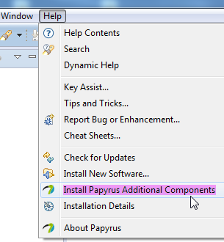 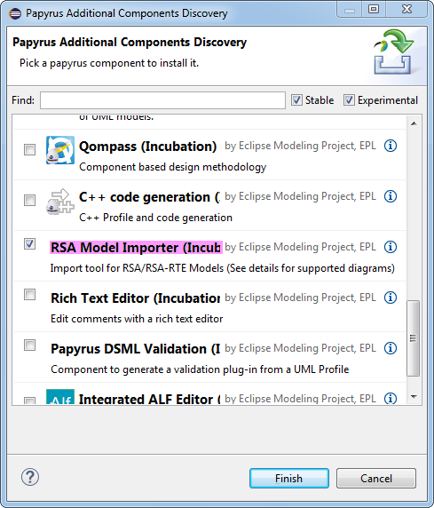

Figure 9‑1: Installing Papyrus Component “RSA Model Importer”

## Import RSA Model into Papyrus

Notes: Each step identifies the tool that is used to execute it. Any ASCII editor can be used instead of Notepad++.  
The import of the ITU-T G.8052 model is used here as an example.

1. Create a new, empty general project (i.e., not a Papyrus project).  
   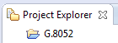
2. Copy the RSA .epx (profile) and .emx (model) files into the empty project folder.  
   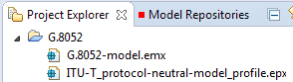
3. Import the RSA model (.emx file) into Papyrus by right-click on the .emx file and then select “Import EMX model”:

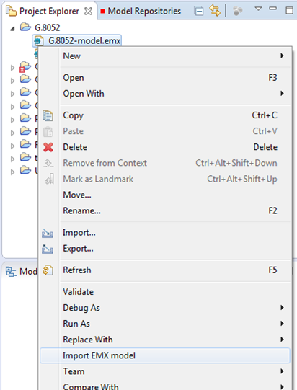

Figure 9‑2: Importing .emx Model

As a result, the RSA .emx file is replaced by the Papyrus model file:  
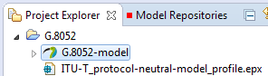

1. Import the RSA Profile model (.epx file) into Papyrus by right-click on the .epx file and then select “Import EMX model” (same as previous step).  
   As a result, the Papyrus profile model file is created:  
   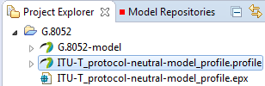

## Replace RSA Profile by Papyrus Profile

This is done by changing the pointer from the .epx (RSA) file to the .uml (Payprus) file.

1. Close Papyrus.  
   Notepad ++: Replace all occurrences of “ITU-T_protocol-neutral-model_profile.epx” by “ITU-T_protocol-neutral-model_profile.profile.uml” in the model .uml file () in the Papyrus Workspace:  
     
   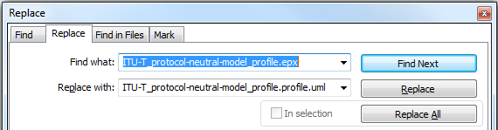

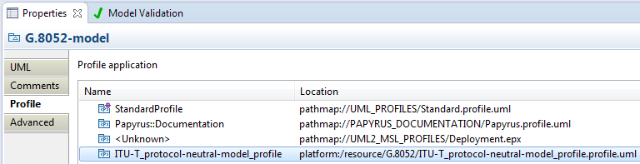

Figure 9‑3: Associated Papyrus Profile

## Remove the “old” RSA files

1. Windows Explorer: Delete the RSA profile .epx file () from the Papyrus Workspace.
2. Windows Explorer: Delete the RSA model .emx file () from the Papyrus Workspace.

# Main Changes between Releases

## Summary of main changes between version 1.0 and 1.1

The following guidelines have been changed/added:

* Eclipse: Migration from Kepler to Mars
* Github: Only one develop branch
* Github: Method for retrieving repositories using the "Download ZIP" button added; this method is just for read only users
* Documentation: New clause on Gendoc added.

## Summary of main changes between version 1.1 and 1.2

* ONF specific text generalized
* Document moved to Open Source SDN
* GitHub work flow for OpenModelProfile added in clause 6.2.
* Description of extracting data from the model into Excel tables deleted.
* Use of Gendoc “fragments” added in clause 8.14.
* Constructing of the Modeling Environment for a new Model described in clause 7.4.

## Summary of main changes between version 1.2 and 1.3

* Adapted to ETSI drafting rules.
* Updated for Papyrus 3.x.x (Oxygen).
* Model infrastructure files (e.g., profiles, style sheet) moved into the Papyrus project.
* Section on “Constructing Modeling Environment for a new Model” completely reworked.
* Installation of specific Eclipse version 4.7.2 “Oxygen” and Papyrus version 3.2.0 RC4 added and warning added to prevent automatic updates.
* Justification for UML package structure added in section 7.4.5.
* Papyrus installation in section 5.2.2 changed to use the update site.

1. Driven by overall delivery schedule and coordinated by the administrators.
2. It is vital that all modelers use the same version of Papyrus to prevent compatibility issues.
3. It is expected that the .notation file will eventually not be necessary and intertwining of class content and model diagrams will be more straight forward.
4. Note that certain special characters such as “[“ should be avoided. Any issues will be covered in the “known issues” document.
5. There are current